**Q: What was the purpose of source C? [Use details from the source and your own knowledge and understanding of the historical context to answer the question]**

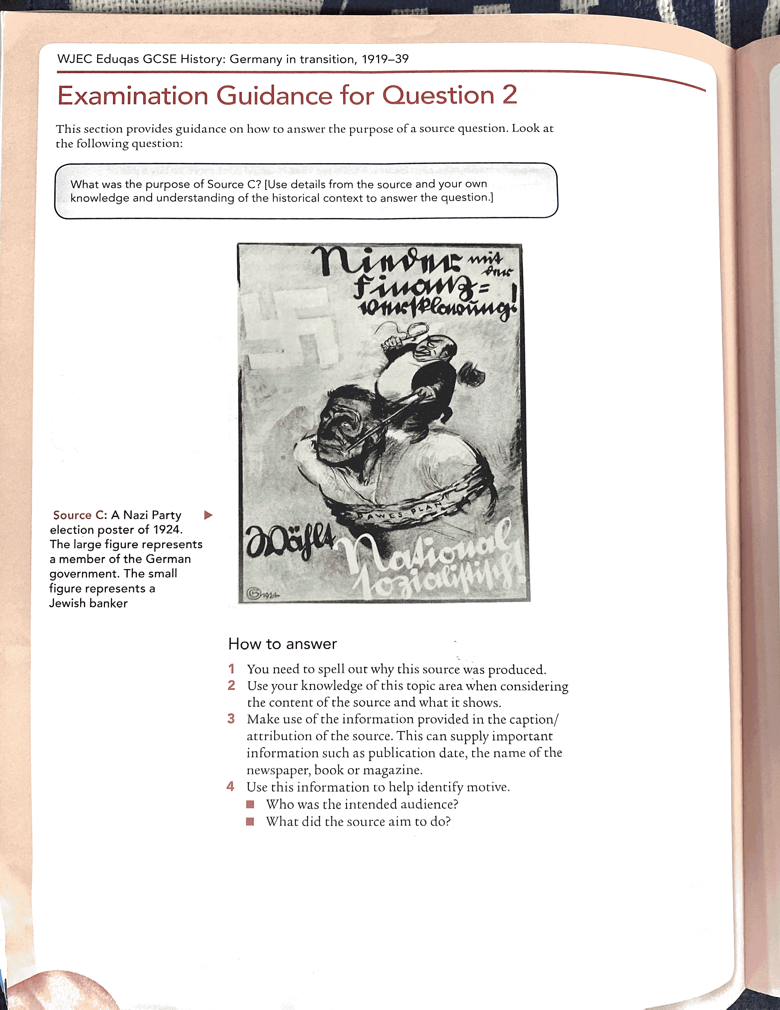Source C: A Nazi Party election poster of 1924. The large figure represents a member of the German government. The small figure represents a Jewish banker.

**Mark scheme:**

|  |  |  |  |  |
| --- | --- | --- | --- | --- |
|  | **AO1 (4 marks- knowledge)** | | **AO3 (4 marks- source analysis)** | |
| **BAND 3** | You have a detailed understanding of the question topic. | 3-4 | You have fully analysed the purpose of the source and have reached a supported judgement. | 3-4 |
| **BAND 2** | You have some understanding of the question topic. | 2 | You have partially analysed the purpose of the source. You have reached a judgement on this. | 2 |
| **BAND 1** | You have a basic understanding of the question topic. | 1 | You have mainly described or paraphrased the source, with little or no evaluation. | 1 |

(Model answer on the following page)

**Model answer:**

**Q: What was the purpose of source B? [Use details from the source and your own knowledge and understanding of the historical context to answer the question]**

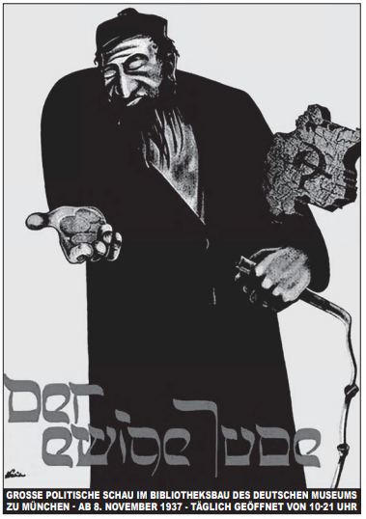

Source B: A poster for an exhibition called ‘The Eternal Jew’, held in Munich from November 1937 to January 1938.

Source C is a Nazi propaganda poster advertising an exhibition called ‘The Eternal Jew’. The main purpose of the source is to advertise the exhibition and to show the German people the Nazi stereotype of a Jew.

The poster shows the Nazi idea of a Jew, the man in the poster is portrayed as being obsessed with money and linked to communism. This is shown by the hammer and sickle on the map of Germany. The main purpose of the source is to encourage Germans to go to the exhibition, where Nazi stereotypes about Jewish people were reinforced. The poster was produced when the anti-Semitic policies of the Nazis were becoming more aggressive, for example, many Jewish businesses were taken over in 1937. Therefore, the purpose of the poster was to spread anti-Semitic ideas and show Jewish people as the enemy and a threat to Germany. This is clear through the link to communism, which was one of the reasons why support for the Nazi Party grew in the early 1930s. The whip in the hand of the man on the poster shows the potential threat this could be to Germany.

Overall, the purpose of the source is to advertise ‘The Eternal Jew’ exhibition to encourage more Germans to go. This was so that the Nazis could spread their propaganda about the danger of Jews and encourage more Germans to support and follow their anti-Semitic policies. The Nazis do this by linking Jews to other political issues at the time, such as the economy and communism.