**Q: Use source A and your own knowledge to describe the events of the Reichstag Fire. [5]**

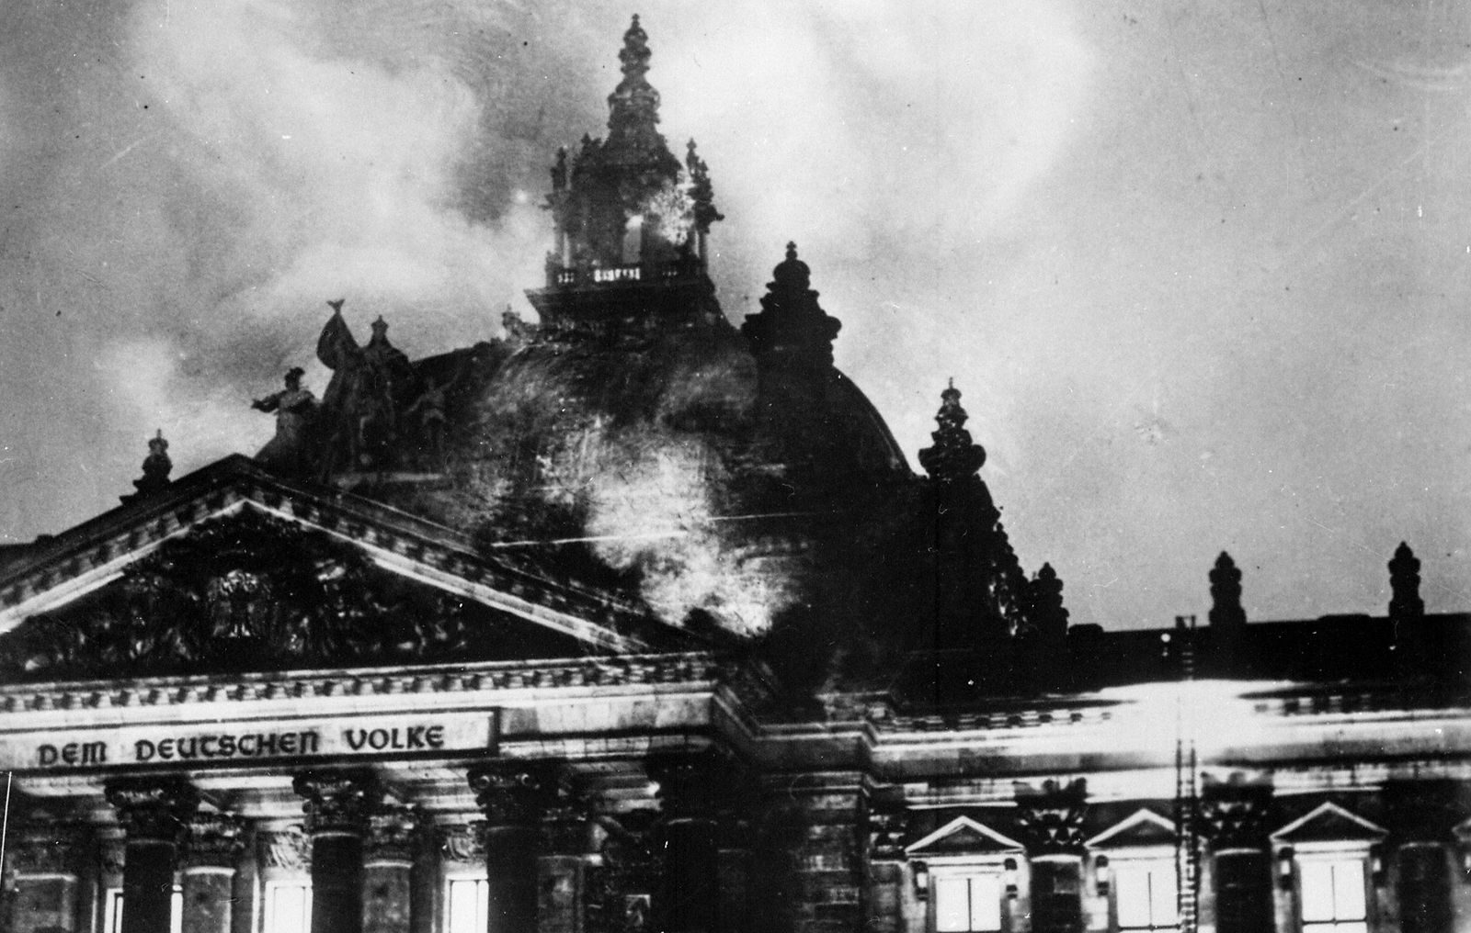

Source A: This photograph shows the Reichstag (German parliament) in flamed on the night of 27th February 1933.

**Mark scheme:**

|  |  |  |  |  |
| --- | --- | --- | --- | --- |
|  | **AO1 (3 marks- knowledge)** | | **AO3 (2 marks- source analysis)** | |
| **BAND 2** | You have detailed understanding of the question topic. | 2-3 | You have accurately analysed the source using your historical context. | 2 |
| **BAND 1** | You have some understanding of the question topic. | 1 | Source is analysed but it is only descriptive. | 1 |

**Model answer:**

**Q: Use source A and your own knowledge to describe the work of Stresemann during the period 1924-9. [5]**

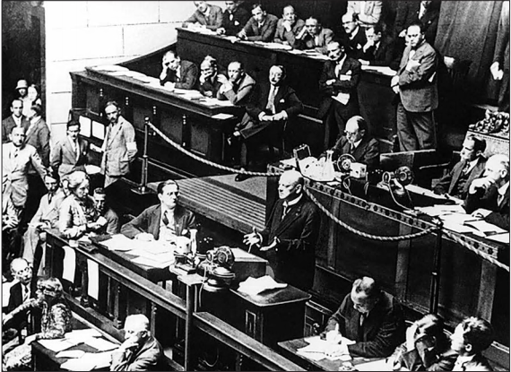

Source A shows how Stresemann played an important role in German politics between 1924-9. He helped to restore stability after the French occupation of the Ruhr and hyperinflation crisis and also ended passive resistance and introduced a new currency called the Rentenmark. Source A also shows Stresemann addressing the League of Nations in the same year that Germany was allowed to join. Leading up to this he also helped implement the Dawes Plan and Young Plan, which tried to tackle the reparation payments.