**The USA Revision Booklet**

**Part I - Economic Downturn & Recovery**

The Wall Street Crash

**Task:** Complete the gap fill below to identify the events that led to the Wall Street Crash.

After the First ______ ______, the USA experienced an __________ boom. The policies of __________ presidents and advanced production used by the ­­­­______ industry helped to further the boom. During the 1920’s, more Americans began __________ in _________ and prices kept rising. In _______ however, shares did not ______ as much as in previous years. The led to a fall in ____________ in the market and a drop in share _______. In 1929, experts and small investors began to _______ and rushed to sell their shares. On the 24th October, 13 million shares were traded and share prices ___________. This event became known as the ________________________.

Economic

Prices

Investing

Wall Street Crash

World War

Rise

Collapsed

1928

Republican

Confidence

Shares

Confidence

Car

Panic

**Task:** What does the graph below tell us about unemployment after the Wall Street Crash? Why might this lead to a great depression? *Explain your answer.*

**Key terms:**

**Economic Boom** – Rapid and significant growth in the economy

**Economic Depression** - A downturn in Economic activity over a long period of time

__________________________________________________________________________________________________________________________________________________________________________________________________________________________________________________________________________________________________________________________________________________________________________________________________________________________________________________________________________________________________________________________________________________________________________________________

Republican attempts to deal with the crisis

**Task**: Rank the following changes made my Hoover in order of effectiveness. (*1 = most effective*  *9 = least effective)*

|  |  |
| --- | --- |
| **Hoovers policies** | **Rank** |
| Hoover followed the Republican ideas of laissez-faire and rugged individualism. This was the belief that people were responsible for their own lives without help from anyone else. |  |
| Assisted farmers with the Agricultural Marketing Act 1930. The government lent money to farmers with the aim at fixing the price levels and ensuring the farmers made a profit from sales. |  |
| Hoover cut taxes on the public by around $130 million. |  |
| Hoover met up with business leaders are requested them to not cut wages or production levels. |  |
| Hoover set up relief agencies (e.g. President’s Organisation for Unemployment Relief) that aimed to promote and co-ordinate local relief efforts. |  |
| Reconstruction Finance Corporation (February 1932). $2 billion worth of loans given to banks, insurance companies and railroads. Corporation aimed to strengthen confidence and create jobs. |  |
| Hoover passed the Hawley-Smoot tariff Act 1930. This protected US farmers by increasing import tax on foreign goods. However, other countries began refusing to trade with USA. |  |
| Hoover won approval from Congress for $1.8 Billion for new construction and repairs to roads and dams across the USA. |  |
| The Emergency Relief Act (ERA) (July 1932). ERA provided $300 million to state governments to help unemployed. Home Loan Bank Act (July 1932) stimulated house building and home ownership. |  |

**Task:** How effective do you think Hoover’s policies were in dealing with unemployment after the Great Depression? *Explain your answer.*

____________________________________________________________________________________________________________________________________________________________________________________________________________________________________________________________________________________________________________________________________________________________________________________________________________________________________________________________________________________________________________

**Task:** Match the left column to the correct description to find out why Hoover was criticised.

**Key:**

Relief

Recovery

Reform

Roosevelt and the New Deal

In November 1932, a presidential election saw Roosevelt (Democrat) beat Hoover (Republican) in a landslide victory- only 6 of 48 states voted for Hoover. Roosevelt’s victory was due both to the unpopularity of Hoover and his policies, and the appeal of Roosevelt and his promise of a New Deal. The aims of the new deal were based upon the three ‘Rs’ – Relief, Recovery and Reform.

**Task:** During the Hundred Days Roosevelt set up numerous organisations dubbed Alphabet Agencies. Use three colours to highlight these organisations to categorise them into the ‘three Rs’ – Relief, Recovery and Reform.

|  |  |  |
| --- | --- | --- |
| Hawley-Smoot Tariff Act. |  | This was due to a rise in unemployment and people moving out of the cities. |
| Bonus Marches. |  | This protected farmers, but meant other countries refused to trade with the US. |
| Policy of individualism. |  | War veterans demanded their bonuses, but Hoover used troops to quash their protest. |
| Hooverville’s being set up. |  | Hoover believed that people should look after themselves. |

|  |  |
| --- | --- |
| **Agricultural Adjustment Act (AAA)** | *Set up to increase farm prices and farmers’ incomes. To achieve this production levels would have to drop. As production feel, prices would rise and farmers would begin to recover. The Supreme Court rejected the Act in 1936.* |
| **Civilian Conservation Corps (CCC)** | *Set up to create jobs for men aged 18-25 who were hobos or living in Hooverville’s. They were offered work in conservation projects, received food, clothing and $1 per day. 1933: 250,000 men in the CCC. 1941: 2 million men had been granted work in the CCC.* |
| **Civil Works Administration (CWA)** | *Set up to create public jobs. By January 1934, about 4 million mainly unskilled Americans were o the CWA’s payroll. Some workers built roads, whilst others scared birds away from buildings or swept leaves in parks.* |
| **Emergency Banking Act (EBA)** | *Set up to restore confidence in the banking system. The Act prevented banks from investing savings deposits in the stock market.* |
| **Farm Credit Administration (FCA)** | *Gave low-interest loans to farmers to help them pay debts. Twenty per cent of farmers benefited from the scheme.* |
| **Federal Emergency Relief Administration (FERA)** | *Provided $500 million for emergency relief through grants to state and local agencies. It was a temporary measure- Roosevelt did not want opponents to think the government was handing out money.* |
| **National Recovery Administration (NRA)** | *Set fair prices, wages and working conditions such as maximum hours and minimum wages.* |
| **Public Works Administration (PWA)** | *Spent $3.3 billion on large scale public works.* |
| **Reconstruction Finance Corporation (RFC)** | *Roosevelt pumped $15 million into Hoover agency. Banks and businesses were able to use some of the money to restart investment.* |
| **Tennessee Valley Authority (TVA)** | *Aimed at regenerating the Tennessee Valley region, which was one of the most depressed regions of the USA.*  *The TVA was responsible for creating a system of dams to generate cheap electricity and control to prevent flooding in order to attract industry to the area.*  *Eventually the work of the TVA covered seven states, an area of 104,000km2 with a population of 7 million people.* |

Opposition to the New Deal

**Supreme Court**

One of the reasons that the Supreme Court opposed some of Roosevelt’s was that the court was dominated by Republican judges. Between 1861 and 1933 there had been only 16 years of Democrat Presidents and therefore few opportunities to nominate Democratic judges.

Out of the 16 cases concerning the Alphabet Agencies which were tried by Supreme Court in 1935 and 1936, judges declared that Roosevelt had acted unconstitutionally in 11 cases. **Individuals**

Huey Long claimed that Roosevelt had failed to share out the nation’s wealth fairly and announced his own plans to do this under the slogan ‘Share Our Wealth.’ Long attracted much attention but was killed before these were put into place.

Catholic Priest, Father Charles Coughlin, criticised the New Deal for not doing enough and labelled Roosevelt as ‘anti-God.’ Coughlin’s influence came from his weekly radio broadcast that attracted over 40 million listeners.

Dr Frances Townsend gained much support from the elderly who opposed the New Deal. He set up ‘Old Age Revolving Pension Plan’, also known as the Townsend clubs that attracted 5 million members by 1935.

**Politicians**

The political opponents of the Democrats, the Republicans, opposed the New Deal because they believed that Roosevelt was doing too much to help people.

The American Liberty League was set up in 1934 to preserve individual freedom and was backed by wealthy businessmen. This league believed the New Deal threatened the constitution and the freedom of the individual.

Some of Roosevelt’s party (Democrat’s) opposed the New Deal. They were especially against the Wagner Act which had given greater power to trade unions.

**Task:** Which of these groups was the biggest threat to the New Deal? *Explain your answer.*

___________________________________________________________________________________________________________________________________________________________________________________________________________________________________________________________________________________________________________________________________________________________________________________________________________________________________________________________________________________________

**Part II - The Economic Impact of the Second World War and Post-War Developments**

Industrial output

**TASK:** For each section below, write a short summary of no more than two sentences.

Big business and the war effort

Roosevelt made use of leading US businessmen to provide for the needs of war. The War Production board was run by a leading industrialist. Furthermore, Roosevelt called on industrialists to ask their advice on meeting the demands of wartime production and setting targets, allowing them to decide which companies would produce particular goods. For example, General Motors produced heavy machine guns and thousands of other war products.

_____________________________________________________________________________________________________________________________________________________________________________________________________________________________________________________________________

The effects of war on the US economy

The Second World War enabled the USA to expand its industrial and military complexes on a huge scale and, by September 1945, it emerged as the most powerful economy in the world. The war gave the USA immense advantages over both its allies and its enemies. The USA became a country where there were always lots of jobs available. It experienced phenomenal economic growth in the post-war years. During the war, US industry was able to expand as a result of the Lend Lease programme to its allies whereby huge amounts of aid were given to Britain, the USSR and Latin America. By 1960, the USA was the strongest economic power in the world.

_____________________________________________________________________________________________________________________________________________________________________________________________________________________________________________________________________

The Workforce

As a result of conscription about 16 million American men and women served in the US armed forces. This meant that many more workers were needed on the home front. This put an end to the serious problem of unemployment caused by the Depression. In 1939, unemployment stood at 9.5 million. By 1944, it had fallen to 670,000. Fourteen million people worked in the factories. Nearly 4 million workers, many of these black Americans, migrated from the rural South to the industrial North. Probably the greatest change was in the employment of women. Although there were already 12 million working women in the USA, a further 7 million joined the workforce.

_____________________________________________________________________________________________________________________________________________________________________________________________________________________________________________________________________

|  |  |  |  |  |  |  |  |
| --- | --- | --- | --- | --- | --- | --- | --- |
|  |  | 1940 | 1941 | 1942 | 1943 | 1944 | 1945 |
| Civilian labour force | Total | 55.6 | 55.91 | 56.4 | 55.5 | 54.6 | 53.8 |
| Unemployed | Total | 8.1 | 5.5 | 2.6 | 1.07 | 0.6 | 1.04 |
| Percentage of labour force | 14.6 | 9.9 | 4.7 | 1.9 | 1.2 | 1.9 |

(Civilian unemployment during the Second World War (numbers in millions)

**Task:** Using the table above, what can we learn about unemployment in the USA in the years 1940-45 and why did this happen?

________________________________________________________________________________________________________________________________________________________________________________________________________________________________________________________________________________________________________________________________________________________________________________________________________________________________________________________________________________________________________________________________________________________________________________________________________________________________________________________________________________________________________________________

US industry after the Second World War

The American domestic market proved to be much more buoyant than had been anticipated. The millions of US citizens who had purchased war bonds now began to cash them in and this amounted to almost US$200 billion. Ordinary Americans wanted to leave rationing behind and buy consumer goods. The automobile industry boomed.

Military spending:

The rise in defence spending helped sustain the economic boom. In the 1950s, defence spending was between US$40 and US$50 billion per year. Billions of dollars were spent on weapons research and development. Many firms were awarded lucrative contracts to provide weapons, research and equipment.

Open trading:

Importantly, world markets began to open up and demand for consumer goods began to rise. Because US industry had not been damaged by air attacks, it meant that the US had a clear advantage over the European countries. Demand from Europe and other markets helped to keep US production high.

Industry and economic expansion:

Economic expansion created greater employment opportunities in many industries. By the end of the 1940s, the USA produced one-half of the world’s manufactured goods: 57 per cent of steel, 62 per cent of oil and 80 per cent of cars.

|  |  |  |
| --- | --- | --- |
| **Affluence** |  | Temporary marked increase in birth rate following the end of the Second World War. |
| **Consumerism** |  | The suburbs or the people living in the suburbs. |
| **Baby Boom** |  | The state of having a great deal of money or wealth. |
| **Disposable income** |  | The idea of having the perfect family, job and house in the suburbs. |
| **Suburbia** |  | Income remaining after deduction of taxes and bills, available to be spent or saved as one wishes. |
| **‘American Dream’** |  | The protection or promotion of the interests of consumers. |

**TASK:** Using the information above, answer the following question:

Explain why the US economy thrived after the Second World War.

________________________________________________________________________________________________________________________________________________________________________________________________________________________________________________________________________________________________________________________________________________________________________________________________________________________________________________________________________________________________________________________________________________________________________________________________________________________

Affluence, consumerism and suburbanisation

**Task:** Match the key terms below to their definitions.

President Truman introduced a programme of economic development and social welfare which became known as the Fair Deal. In his 1949 State of the Union Address to Congress, Truman stated that ‘Every segment of our population, and every individual, has a right to expect from his government a fair deal’. This policy was continued by his successor, Eisenhower and led to the prosperity of the 1950s which is evidenced by the ownership of consumer goods such as cars, televisions, refrigerators and washing machines rising. There were several reasons for this.

|  |  |
| --- | --- |
| Americans spent US$100 billion they had saved during the Second World War. Much of this money went on consumer goods, especially television and cars. |  |
| Hire purchase, known as consumer credit, increased by 800 per cent between 1945 and 1957. |  |
| The improved efficiency of the workforce meant that consumer goods could be produced more cheaply, which kept down prices. |  |
| The growth in population provided a greater demand for goods. |  |
| The Korean war (1950-53) and the ongoing Cold War meant that US industry was kept busy turning out new weapons, which led to big orders for industries such as steel, coal and electronics. |  |

**Task:** Rank the factors in the table in order of importance with regards to the impact they had on the prosperity of the 1950s.

**Task:** Answer the question, what was the most significant factor that led to the prosperity of the 1950s for many American citizens?

____________________________________________________________________________________________________________________________________________________________________________________________________________________________________________________________________________________________________________________________________________________________________________________________________________________________________________________________________________________________________________________________________________________________________________________________________________________________________________________________________________________________________________________________________________________________________________________________________________________________________________________________________________________________________________________________________________________________________________________________________________________________________________________________________________________

Suburbia was a new development in the late 1940s and 1950s. Many middle-class families abandoned the centre of cities and moved to new homes in the suburbs. The suburbanisation of the USA was a central part of the campaign to create the ideal American family. This movement was due to several factors:

* __________ embodied the ‘American Dream’ for many young couples as a place where they could own their own ________ and raise their children away from the ________ of city life.
* Houses were reasonably priced and made __________ to newly married middle-class couples through low-interest __________.
* Most families had at least one ____, which meant that people no longer had to live close to their place of ______.
* The ________ growth and affluence of the post-war years made these new houses and consumer goods affordable to an __________ number of Americans.
* A baby boom, between 1945 and 1960, increased the population by about 40 million and increased the _______ for new homes. The number of home owners increased __________.

*Suburbia homes dangers affordable mortgages car work economic increasing demand significantly*

**Task:** Use the words given in order to fill in the gaps in the information above.

**Task:** Explain why people moved to the suburbs in the 1950s.

_____________________________________________________________________________________________________________________________________________________________________________________________________________________________________________________________________________________________________________________________________________________________________________________________________________________________________________________________________________________________________________________________________________________________________________________________________________________________________________________________________________________________________________________________________________________________________________________________________________________________________________________________________________________________________________________________________________________________________________________________

Poverty in the midst of plenty

Not every American shared in this new-found affluence.

**Task:** Match each factor below to the correct statement.

|  |
| --- |
| Health |
| Location |
| Ethnicity |
| Class |

|  |
| --- |
| 40% of people of benefits in NY went to African-Americans. |
| Many Americans were part of an underclass that remained below the poverty line (29%). |
| There was no national health service and the cost of care increased rapidly meaning that if you were ill you ended up poor. |
| People’s income was affected by where they lived. For example, southern states paid their workers less than the north/west. |

Task: Explain why some Americans did not experience the new-found affluence of the 1950s.

________________________________________________________________________________________________________________________________________________________________________________________________________________________________________________________________________________________________________________________________________________________________________________________________________________________________________________________________________________________________________________________________________________________________________________________________________________________________________________________________________________________________________________________________________________________________________________________________________________________________________________________________________________________________________________________________________________________________________________________________________________________________________________________________________________________________________________________________________________________________________________________________________________________________________________________________________________________________________________________________________________________________________________________________________________________________________________

**Part III - The Issue of Civil Rights, 1941-70**

**Key Terms**

|  |  |
| --- | --- |
| **Term** | **Definition** |
| Jim Crow Laws | State and local laws that enforced racial segregation in the Southern United States. |
| Segregation | The action or state of setting someone or something apart from others. |

**Contribution of black Americans to the war effort:**

The Second World War highlighted the racism and discrimination that existed in the USA and its armed forces. Many black Americans enlisted in the US forces and formed the **Jim Crow** army. However, the treatment of said soldiers lacking to say the least.

* Before 1944, black soldiers were not allowed into combat in the Marines
* Black people were employed as cooks and labourers
* Black women served as nurses but were only allowed to treat black soldiers
* The US Air Force would not accept black pilots
* In each armed service, black Americans performed menial tasks and found promotion difficult
* Only blood from black soldiers could be used to treat black injuries
* Discrimination was the worst in the navy, with black soldiers being given the most dangerous jobs

**Task**: Describe the treatment of black Americans in WWII

____________________________________________________________________________________________________________________________________________________________________________________________________________________________________________________________________________________________________________________________________________________________________________________________

**Task:** Highlight whether the employment opportunities for black Americans improved following WWII.

Key: Did improve Did not improve

|  |  |  |  |
| --- | --- | --- | --- |
| In 1914, Philip Randolph organised a ‘March on Washington’. This led to Roosevelt issuing Executive order 8802 that stopped discrimination in industrial and government jobs. | Black workers only generally earned one-half of what white workers earned. | The Fair Employment Practices Commission was set up to threaten companies who refused to employ black Americans. | Many women used the war to become nurses, but were only permitted to tend to black soldiers. |
| The migration of black America to industrial cities of the North had created greater racial tension in the south. It led to the race riots in 47 cities. | The FEPC could not force companies to hire black workers. | The number of black Americans employed in government service rose from 50,000 to 200,000, with 2 million black Americans working in industry by the end of the war. | Trade union involvement increased and black membership rose from 15,000 in 1935 to 1.25 million in 1945. |

**The situation by the end of the 1940’s:**

Source I: From a letter by Harry S. Truman, 18 August 1948, describing his revulsion at lynching:

*The main difficulty with the South is that they are living eighty years behind the times and the sooner they come out of it the better it will be for the country and themselves. I am asking for equality of opportunity for all human being and, as long as I stay here, I am going to continue that fight. When the mob gangs can take four people and shoot them in the back and everybody in the country is acquainted with who did the shooting and nothing is done about it, that country is in a pretty bad fix.*

**Task**: What does the source tell you about the condition of the South America in reference to Civil Rights?

____________________________________________________________________________________________________________________________________________________________________________________________________________________________________________________________________________________________________________________________________________________________________________________________

**Brown vs. Topeka:**

The first case to challenge desegregation in schools was the Brown vs. Topeka case. Lawyers from the NAACP (National Association for the Advancement of Colored People) created evidence for the Supreme Court that segregated schools caused emotional and psychological harm. The judgement came 18 months later that separate schools were not equal and a push for desegregation should be made.

**Task:** Highlight the successes and failures of the Browns vs. Topeka case.

* 300,000 black children were attending schools that had formerly been segregated.
* 2.4 million black southern children still educated in Jim Crow Schools (Separated schools)
* The Supreme Court supported the desegregation in schools
* 450 laws passed in the next two years in southern states to prevent desegregation in schools

**Little Rock Nine:**

After the Brown vs. Topeka case, Little Rock Nine High School in Arkansas decided to allow nine black students to enrol. These students faced opposition to integrating into school life. For example, they were prevented from entering by the state governor, white students harassed them, and police escorted them home because their safety could not be guaranteed. This led to Eisenhower’s involvement with Federal troops to ensure the safety of the Little Rock Nine.

**Task –** Evaluate the significance of Little Rock Nine

|  |  |
| --- | --- |
| **Significance** | **Rank** |
| It involved the president, thus demonstrating that civil rights was an issue that could no longer be ignored. |  |
| It demonstrated that states would be overruled by the federal government when necessary. |  |
| The demonstrations were seen on television and in newspapers across the world. It did the USA no good to be seen as an oppressive nation when it was criticising communist countries for not allowing their citizens basic human rights. |  |
| Many US citizens saw, for the first time, the racial hatred that existed in the southern states. |  |
| It did help to moderate some of the views held by white Americans at the time. |  |
| Black activists were beginning to realise that reliance on the federal courts was not enough to secure change. |  |
| The issue of civil rights was now at the heart of US politics. |  |

**Montgomery bus boycott:** Complete the Gap Fill

Segregation on _______ transport had long been a problem for ________ Americans. On December 1st ________, Rosa Parks refused to move out of her seat to accommodate a white American in a cramped bus.

In response to this, Rosa Parks was ________. Local civil rights activists, such as ________________. They planned a ________ for the evening of the trial and the NAACP began to prepare its _______ challenge to the segregation ______. At the meeting, the Montgomery Improvement Association (MIA) was established to oversee the continuation and maintenance of the boycott. King was chosen to lead the ______.

During the boycott, rather than catching the ______, many citizens opted for black run taxi companies, walking, biking and car sharing to get to work. This caused the bus companies to lose _________. This boycott did meet ____________, with one of the examples being King’s house _______________ during 1956.

The MIA took the issue of segregation to the ________ court and the court accepted that _____________ was unconstitutional. The Supreme Court upheld the decision of the federal court and it paved the way for travelling on __________ busses.

public

firebombed

1955

black

federal

bus

integrated

Martin Luther King

laws

segregation

resistance

resistance

legal

arrested

money

MIA

**Challenge:** Explain why the boycott was significant for the development of the Civil Rights movement.

____________________________________________________________________________________________________________________________________________________________________________________________________________________________________________________________________________________________________________________________________________________________________________________________

Other significant movements towards civil rights equality were the sit-ins and freedom riders.

**Task:** Highlight Key information.

The sit-in protests started in Greensboro. On 1st February 1960, four black students walked into F.W. Woolworths and demanded to be served in a whites-only lunch counter. The popularity of the sit-ins increased, and therefore the attention it received also increased. Some were arrested for trespassing. The students then began to boycott any shop in Greensboro that had a segregated counter. These students used peaceful strategies to push their cause for desegregation.

In December 1960 the Supreme Court decided that all bus stations and terminals that served interstate travellers should be integrated. The Congress Of Racial Equality (CORE) wanted to push this theory with the use of freedom riders. The first freedom rides aimed for interstate travel from Washington DC to New Orleans. White-only facilities were used along the way to ensure integration. There was very little trouble at the beginning of the journey, however, southern states posed more of an issue, with many freedom riders being beaten and imprisoned. In response to this, on the 22nd September the Interstate Commerce Commission issued a regulation that ended racial segregation in bus terminals.

**The role of Martin Luther King:**

The civil rights issue exploded in 1963. There was still no federal law that made southern state integrate public facilities. In order to avoid desegregation, parks, playgrounds and swimming pools were all closed in the city of Birmingham, Alabama. King aimed to challenge the city with sit-ins and marches. Following multiple demonstrations, King’s imprisonment and student/children protests, it was agreed that the desegregation would take place in the city. A consequence of the violence was Kennedy’s decision to bring about the Civil Rights Bill.

King was also well known for his march on Washington in 1963. A combination of the civil rights organisations took part in organising the march. The march began as a call for jobs and freedom, but it broadened its aims to cover the whole of the civil rights movement. There was also the demand for the passage of Kennedy’s Civil Rights Bill. King was the last speaker at the Washington march, where he delivered the well-known ‘I have a dream’ speech that targeted the American Declaration of Independence and looked to the future for racial equality.

The civil rights movement hit a momentary halt with the bomb attack against four black girls in 1963, as well as Kennedy’s assassination in 1963. However, the new president, Lyndon Johnson, pushed Kennedy’s Civil Rights Bill through Congress, it became law in 1965, however, did not guarantee black Americans the vote. In response, King led the march from Selma to Birmingham which faced attacks from state police. It became known as ‘Bloody Sunday’. Johnson responded by pushing through the Voting Rights Act in 1965. King’s methods had been a success to achieve greater civil rights.

**Task:** Describe the role of MLK in the civil rights movement

____________________________________________________________________________________________________________________________________________________________________________________________________________________________________________________________________________________________________________________________________________________________________________________________

**The role of Malcom X:**

The most famous member of the Nation of Islam was Malcolm X who saw the methods of MLK to be slow and limiting. This group of supporters preferred separatism (total separation and independence from a larger group) and Malcom X was very effective at gaining a following with his oratory skills.

Many mainstream civil rights movements saw the Nation of Islam had a ‘hate-white’ approach, which did not fit in to civil equality. Malcom X believed that violence could be justified not only for self-defence, but also as a means to secure a separate black nation. Following his trip to Mecca, he decided to leave the Black Muslims and set up his own Muslim Mosque. He came to believe that Islam was the solution to racial discrimination. This however was met with opposition, particularly among Black Muslims. This eventually led to his assassination in 1965.

**Task:** Explain the similarities and differences between Malcom X and MLK

____________________________________________________________________________________________________________________________________________________________________________________________________________________________________________________________________________________________________________________________________________________________________________________________

_______________________________________________________________________________________________

**Civil Rights Legislation:**

The Voting Rights Act 1965

* Ended the literacy tests that excluded many black Americans from voting
* Ensured federal agents could monitor registration – and step in if it was felt there was discrimination
* By the end of 1965, 250,000 black Americans had registered to vote, and a further 750,000 by 1968

The Civil Rights Act 1964

* Segregation in hotels, motels, restaurants, lunch counters and theatres was banned
* Placed the responsibility on the federal government to bring cases to court when discrimination occurred
* Businesses engaged with the government were monitored to make sure there was no discrimination
* Black students given equal rights to enter public places, including schools
* Fair Employment Practises Commission, was established on a permanent basis (pushed for black hiring)
* Created the Equal Opportunity Commission (EEOC) to implement the law

**Task:** Which civil rights legislation was more significant? Why?

____________________________________________________________________________________________________________________________________________________________________________________________________________________________________________________________________________________________________________________________________________________________________________________________

**Race riots in the 1960’s:**

Despite civil rights laws, many young black Americans were still frustrated with the high unemployment rates, continuing discrimination and poverty. Racial violence peaked in the summer of 1967, with riots in 125 US cities.

**Task:** What does the source show you about the riots in Detroit in 1967?

__________________________________________________________________________________________________________________________________________________________________________________________________________________________________________________________________________________________________________

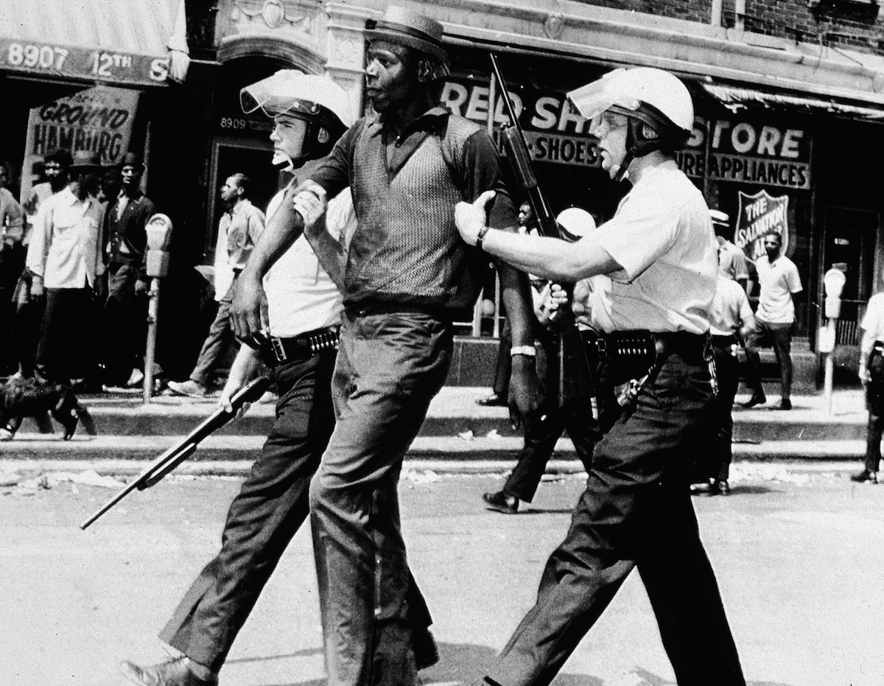

**The Black Power movement:**

The Black Power movement was predominantly focused on pursuing the civil rights movement even further than its predecessors. Individuals such as Stokely Carmichael wanted blacks to take responsibility for their own lives and reject white help.

The Mexico Olympics in 1968gained tremendous publicity for the Black Power movement. The winning sprinters wore part of the Black Power movement uniform and used their body language to show their pride as black Americans. However, these individuals were criticised for bringing politics into sport, and received multiple death threats upon returning home.

Source A: From a press conference given by Tommie Smith in October 1968, following the Olympic medal ceremony

*If I win, I am American, not a black American. But if I did something bad, then they would say I am a Negro. We are black and we are proud of being black. Black America will understand what we did tonight.*

**Task:** What impression does Source A give about the current racial climate in America?

____________________________________________________________________________________________________________________________________________________________________________________________________________________________________________________________________________________________________________________________________________________________________________________________

**The Black Panther movement:**

The Black Panther movement was formed in 1966 by Huey Newton and Bobby Seale. They were heavily influenced by Malcom X. The Panthers had a 10-point programme and were prepared to use revolutionary means to achieve their aims.

Source B: The Black Panthers’ 10-point programme, October 1966

1. *Freedom. We want power to determine the destiny of our Black community.*
2. *We want full employment for our people*
3. *We want an end to robbery by the white man of our Black Community.*
4. *We want decent housing, fit for the shelter of human beings.*
5. *We want education for our people that exposes the true nature of American society and true history.*
6. *We want all black men to be exempt from military service.*
7. *We want an immediate end to police brutality and murder of black people.*
8. *We want freedom for all black men held in federal, state, county and city prisons and jails.*
9. *We want all black people when brought to trial to be tried in court by a jury of their peer group or black communities.*
10. *We want land, bread, housing, education, clothing, justice and peace*

**Task:** Which of these aims do you think MLK would have opposed and why?

______________________________________________________________________________________________________________________________________________________________________________________________

**Part IV - Political Change 1960-2000**

**John F. Kennedy 1961-1963**

When Kennedy became President, he wanted a fairer society for all. His policy became known as the ‘New Frontier’. He found it difficult for the following reasons:

* He only had a small majority.
* He was young and inexperienced.
* People thought the New Frontier was too radical.
* He was the first Catholic President – Protestant politicians were suspicious.
* Southern Congressmen from both parties disliked his commitment to civil rights.

TASK: Categorise the following parts of the New Frontier into: *Civil Rights, The Economy* and *Social Reform.*

|  |  |  |  |
| --- | --- | --- | --- |
| Kennedy appointed 5 federal judges, including Thurgood Marshall. Marshall was a black American and was a leading civil rights activist. | Kennedy deliberately decided not to balance the budget in order to increase economic growth and reduce unemployment. | Kennedy planned to increase the minimum wage from US $1.00 to $1.25 an hour. | Kennedy threatened legal action against the state of Louisiana for refusing to fund schools that were not segregated. |
| He introduced a general tax cut. More spending would mean more goods sold. | Kennedy planned to start Medicare, a cheap system of state health insurance. | The Social Security Act 1962 gave greater financial help to the elderly and unemployed. Social Security benefits were extended to each child whose father was unemployed. | The Housing Act 1961 provided cheap loans for the redevelopment of inner cities. |

**Lyndon Johnson 1963-1969**

Lyndon Johnson took over as President when Kennedy died. He took on the work of Kennedy, and spoke of a ‘Great Society’ which declared war on poverty. Like Kennedy he wanted to end racial injustice, as well as to improve areas Kennedy could not, such as medical care for the poor. Johnson was an experienced politician, so he was able to pass laws that Kennedy was unable to.

TASK: Put the following Johnson achievements in the same categories as you did for Kennedy.

|  |  |  |  |
| --- | --- | --- | --- |
| The Civil Rights Act of 1964 banned discrimination in public places and employment. | Introduced the Medical Car Act in 1965 which provided Medicare (for the old) and Medicaid (for the poor). This was to make sure that all Americans had access to healthcare. | Minimum wage was increased from US$1.25 to US$1.40 an hour. | In 1967, the Supreme Court declared that all laws banning mixed-race marriage were to be removed. |
| Johnson cut taxes to give consumers more money. This was to help businesses grow and to create more jobs. | Employed people to make sure that voting procedures were carried out properly, as stated in the Voting Rights Act. | Improved railways and highways. | Spent US$1.5 billion on the Head Start Programme so that teachers can help provide further education for the poor. |

Despite these successes, Johnson’s good work was overshadowed by US involvement in the Vietnam War. Money was diverted from the great society to be spent instead on the war.

TASK: What is the message of this cartoon…

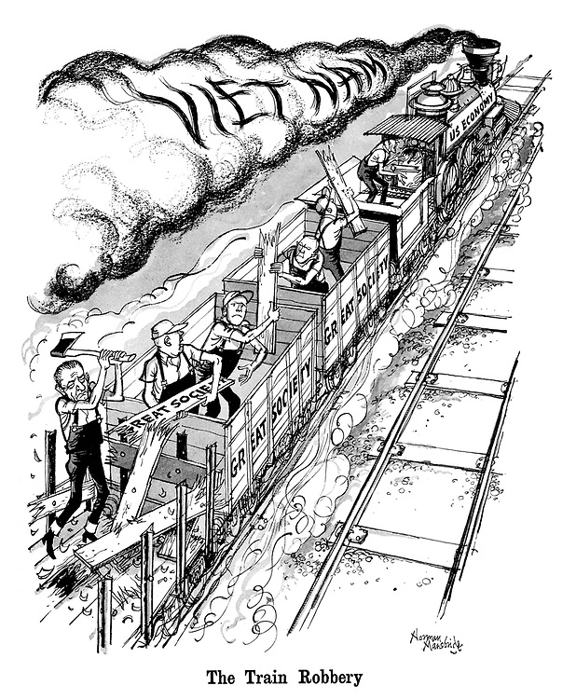

…………………………………………………………….

…………………………………………………………….

…………………………………………………………….

…………………………………………………………….

…………………………………………………………….

…………………………………………………………….

…………………………………………………………….

…………………………………………………………….

…………………………………………………………….

…………………………………………………………….

…………………………………………………………….

…………………………………………………………….

…………………………………………………………….

…………………………………………………………….

…………………………………………………………….

**Richard Nixon 1969-1974**

TASK: Put these events of the Watergate Scandal in the correct order…

|  |  |
| --- | --- |
| **Event** | **Number** |
| The Washington Post reported that all five members were appointed by CREEP. Nixon denied involvement of himself and his advisors, and won the 1972 election. |  |
| A Senate Committee was set up to investigate. This was televised, and one White House official claimed Nixon had directed the cover-up. |  |
| In order to win the 1972 election, Nixon set up CREEP. He gave them $350,000 for ‘dirty tricks’. |  |
| Congress decided to impeach Nixon, which would put him on trial. Nixon resigned as President. |  |
| All of the burglars were convicted. One claimed there had been a White House cover up – again Nixon denied any knowledge, but did admit his advisors had known. |  |
| It emerged that Nixon had recorded his private conversations. He was instructed to hand over the recordings, and after initially refusing, he was made to. The tapes showed his involvement in the dirty tricks campaign. |  |
| Five members of CREEP were arrested for breaking into the Democrats Watergate offices. They had been planting bugging devices |  |

**Ronald Reagan 1981-1989**

When Reagan became President, he was facing severe economic problems. Reagan decided that he would cut taxes for businesses and the rich, in the belief that this would trickle down to the poor. He cut welfare spending by $20 billion per year, he cut taxes by $33 billion, and he made the elderly pay more for health care.

TASK: Rank these consequences of Reaganomics, in terms of the most severe for America.

|  |  |
| --- | --- |
| **Consequence** | **Rank** |
| The government could not pay for services without taxes. |  |
| Reagan ended up increasing government spending. |  |
| National debt rose to its highest ever level – almost $1 trillion. |  |
| The deficit was higher than all other US Presidents combined. |  |
| A severe stock market crash occurred in 1987 – the worst since 1929. |  |
| American industry moved into recession. |  |

Regan had several other policies:

* Several of his space programme plans failed in 1986, including the Challenger exploding seconds after take-off and the failure of the Delta rocket.
* He believed that some damage to the environment was the price to pay for a stronger economy. Most Americans disagreed.
* Reagan angered civil rights organisations by originally opposing making MLK’s birthday a national holiday, as well as through his opposition to abortion.
* Reagan was initially dismissive towards the problem of AIDS, but he eventually spent $2.3 billion on research.
* He declared a ‘War on Drugs’, and in 1988 he created the Office of National Drug Control Policy.

**George H. W. Bush 1989-1993**

George H. W. Bush took over as President from Reagan. He was a Republican, and was expected to continue with Regan’s policies.

Task: Fill in the gaps

George Bush had the reputation of a _________________ and was willing to continue with Reagan’s ______________. During his election campaign, Bush had promised to __________________, but he was forced to go back on his word and ______________. He cut military spending and increased taxes on _______________. However, the budget deficit continued to rise to ____________. This along with the ___________ reduced government income from taxation even more.

**Bill Clinton 1993-2001**

Task: Fill in the gaps

Bill Clinton defeated _______________ in the election campaign of ______. Clinton was a democrat, despite the two previous presidents being __________. Clinton had very different opinions on the ____________ and _______________. When Clinton first became president, the gap between the richest and the ___________ citizens in America had grown even _________.

WORDS FOR BOTH BUSH AND CLINTON:

|  |  |  |  |  |  |  |
| --- | --- | --- | --- | --- | --- | --- |
| Safe pair of hands | economy | recession | Luxury items | Cut taxes | 1992 | $300 billion |
| Social welfare | wider | Increase them | poorest | Bush | policies | Republican |

Clinton had two main areas of success:

* The economy – the budget was balanced, the stock market tripled, unemployment was low, 22 million jobs were created and home ownership increased.
* Welfare and social reforms – minimum wage was introduced, and ante-natal care for mother helped the infant mortality rate reach record lows. However, his universal health insurance plans were rejected by congress.

This good work was also overshadowed by the scandal where Clinton had an affair with a member of the White House staff, Monica Lewinsky. He originally denied this, but eventually was forced to publically apologise.

**Summary**

Task: Write down the name of the President each statement refers to…

1. Increased national debt to the highest figure ever recorded, almost $1 trillion

2. Won by a narrow margin in the 1906 election

3. An experienced politician who was good at making deals with Congress

4. Made a public apology following the publication of evidence showing he had an affair

5. Passed the Americans with Disabilities Act, 1990

6. Destroyed the reputation of the US government as he made it look corrupted

7. Recorded all conversations that took place in the Oval Office, in the White House

8. Passed the Civil Rights Act (1964) and the Voting Rights Act (1965)

9. Was assassinated in 1963

10. Lost support of women when he opposed abortion

**Part V - Social Change 1960-2000**

**Changes in music, entertainment, media and literature**

Music

**Task:** Match the following decades with the artists and genre.

|  |  |  |
| --- | --- | --- |
| 1950s |  | Disco music became popular, with artists such as Donna Summer and the Jacksons, and this was further popularised by the film ‘Saturday Night Fever’. |
| 1960s |  | Elvis Pressley burst onto the scene, with hits such as ‘Hound Dog’ and ‘Heartbreak Hotel’. He popularised the genre of rock and roll. |
| 1970s |  | Rap and hip hop music developed from the disco music, with artists such as Jaz-Z becoming popular, and reaching number 1 in the album charts. |
| 1980s-2000 |  | British groups such as the Beatles and the Rolling Stones took the USA by storm, whilst the Beach boys were an America rock band. |

Cinema

**Task:** Write the definitions for the following terms…

* Drive-ins…
* Multiplexes…
* Anti-heroes…
* Blockbusters…

Television

**Task:** Fill in the gaps in the following paragraph.

In 1946 there were only 7000 ____________ within American homes, compared to 50 million in ______. The average family watched six ______ of television a day, with cable and _________ becoming popular in the 1980s. Americans liked programmes such as game shows and funny shows. The ‘__________’ became one of the most popular styles of programme, such as ‘The Lone Ranger’, giving an idealised image of the __________ West.

Many shows portrayed the American ________, of the ideal family, ideal _______ and neighbourhoods. People began to accept what was on television because they were eyewitnesses to _______ as never before. There were very few _______ or religious minorities represented on television. Those who did appear were usually shown to be working for ________ people.

There were soap operas such as ‘The Doctors’ and _________ chat shows such as ‘The Jerry Springer Show’.

|  |  |  |  |  |  |
| --- | --- | --- | --- | --- | --- |
| hours | American | televisions | Western | satellite | 1960 |
| events | daytime | dream | racial | white | schools |

Information Technology

Categorise the following developments into *PCs*, the *internet*, and *gaming.*

|  |  |  |
| --- | --- | --- |
| In 1991 the first user friendly interface to the internet was developed. | Bill Gates set up his company Microsoft in 1975. | The release of Windows 98 had the Microsoft browser integrated. |
| The first commercially viable computer game was Computer Space in 1971. | Nintendo introduced the first modern games console in the 1980s. | Apple Computer was set up by Steve Jobs in 1975 |

Literature

There was a quest to write a novel which defined the meaning of being American. Finish these book titles…

* To Kill a….
* The Catcher in the…
* The Naked and the…

There were also many books that challenged the traditional conservatism of American society. The writers are often referred to as the ‘Beat Generation’ or Beatniks. An example of this was Betty Friedan’s ‘The Feminine Mystique’. This challenged the traditional role of women in American Society.

**Changes in Youth Culture**

1950s

In the 1950s, young people rebelled against their parents, forming gangs, cruising in cars, attacking property and drinking heavily. They wore their own distinctive clothes and listened to their own style of music.

There were three main reasons for this:

* They had more money to spend - between $10-15 a week, compared with $1-2 in the 1940s.
* They grew up in the shadow of nuclear war - they felt the world could end so they wanted to enjoy today.
* Films like ‘Rebel Without a Cause’ staring James Dean were targeted at young people, establishing anti-heroes.

TASK: In your opinion, which was the biggest reason behind the growth of the rebellious youth culture?

Youth Counterculture

In the late 1950s and into the 1960s, young people continued to develop their own counterculture. Hair was grown long, beards were common, jeans were worn. Alongside this, illegal drugs increased and the introduction of the contraceptive pill encouraged greater sexual freedom.

Other young people would become hippies. Annotate the image below, showing key details about hippies appearance and behaviour. Two have been done for you.

Bearded

Peaceful

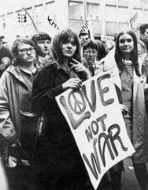

The hippy movement was concerning for older generations because:

* Hippies often refused to work.
* They experimented with drugs.
* They were middle class and rejected all the values that their parents believed in.

**Student Protest**

In the 1960s, students became heavily involved in the civil rights movement, freedom of speech and education, and were opposed to the war in Vietnam.

This protests came to a head with the Kent State University in 1970. Watch this video to remind yourself what happened: <https://www.youtube.com/watch?v=9Pwro3vCUdU>

**The changing role of women**

The role of women changed from before WW2, when women had very few career opportunities, to during the war when they were required to work in the munitions factories. Following the war, many women reverted back to their old lifestyles, however there was some progress.

Task: Categorise the following facts into: *Before WW2, During WW2* and *After WW2.*

|  |  |  |
| --- | --- | --- |
| Women worked in shipyards, munitions factories and aircraft factories. | Women who worked were viewed with suspicion. | Very few career opportunities. |
| Women gave up their jobs to men who returned. | Women had traditional roles as wives and mothers. | More women went to university. |
| Women could be dismissed from their job when they married | Women served in the army. | Women worked in typically female professions, like nursing and teaching. |

The 1960s

In the 1960s the amount of women in work was increasing, however they were not being treated equally. Eleanor Roosevelt set up a report about women’s rights at work, which was published it 1963. It found that:

* 95% of company managers were men
* 7% of doctors were women
* 4% of lawyers were women
* Women only earned 50% of wages of men, for doing the same job.

Betty Friedan was disillusioned with the slow rate of progress, and in 1966 she set up the National Organisation for Women (NOW). By the 1970s it had 40,000 members, who organised demonstrations. They secured $30 million in back pay owed to women who had not been paid wages equal to men.

The Women’s Liberation Movement had more radical aims than NOW, however their radical methods, such as burning bras and crowning a sheep ‘Miss America’, often did more harm than good.

TASK: Categorise the following achievements into *Education, Employment* and *Human Rights…*

|  |  |
| --- | --- |
| **Date** | **Achievement** |
| 1963 | Equal pay for the same job. |
| 1964 | Civil Rights Act – cannot discriminate based on gender. Not taken seriously, so not fully enforced. |
| 1972 | Educational Amendment Act – girls would follow the same curriculum as boys. Took a long time to filter through. |
| 1972 | Supreme Court ruled that the US constitution gave men and women equal rights. |
| 1973 | Women were given the right to have an abortion in 46 states. |
| 1978 | The Pregnancy Discrimination Act banned employment discrimination against pregnant women |
| 1981 | Sandra Day O’Connor was the first woman to be appointed to the US Supreme Court. |
| 1983 | Dr Sally Ride became the first American woman in space. |
| 1984 | Geraldine Ferraro was the first woman Vice-Presidential Candidate for a major party. |
| 1994 | Gender Equity in Education Act trained teachers in gender equality, promote girls maths and science and prevent sexual harassment. |

**Part VI - Cold War Rivalry**

**Reasons for US involvement in the Cold War**

During the Second World War, the USA and the USSR worked together out of necessity. However, once Hitler was defeated relations between the two superpowers began to deteriorate.

In the years after 1945, the USA and the USSR became involved in the Cold War for several reasons.

**Task:** Match each reason to the correct description….

|  |  |  |
| --- | --- | --- |
| Fear of Communism |  | Truman didn’t trust Stalin and was convinced that he was going to take over the rest of Europe. Truman was determined to stand up to the Soviets and developed the atomic bomb as a way of doing this. |
| Soviet expansion in Eastern Europe |  | These were meetings that took place following WWII and were where the future of Germany was discussed. The USA and the Soviet Union disagreed over how much Germany should pay in reparations and how the country should be governed. |
| Attitude of Truman |  | The USA believed in capitalism, so feared the spread of Communism. Especially considering the Bolshevik Revolution in 1917 hoped to spread the communist ideology worldwide. |
| Yalta and Potsdam Conferences |  | This was sent by George Kennan, who worked at the US embassy in Moscow. He explained how the he saw the USSR as aggressive and suspicious and recommended firm action by the USA. This greatly influenced Truman’s policies. |
| The Long Telegram |  | The Soviet Union had freed a lot of Eastern Europe from the Nazis. The Red Army stayed there and established Communist governments in countries such as Poland, Romania and Bulgaria. |

**The Truman Doctrine and the Containment of Communism**

**Task:** Complete the gap fill below to find out about the Truman Doctrine and policy of containment

In 1947, Britain told the USA that they could no longer afford to give financial aid to _______________ and Turkey. The US were worried that these two countries would come under ______________ influence. In a famous speech given in _____________________, Truman announced that the US were stepping in with the ___________________ aid. The speech marked a _______________________________ in US foreign policy. This became known as the policy of _______________________ where the US acted to try and stop the spread of______________________.

Soviet

turning point

financial

communism

March, 1947

Greece

containment

**Task:** Read through the consequences of the Truman Doctrine below, rank them from 1-5 to show how important they were.

|  |  |
| --- | --- |
|  | The Greek government was able to defeat the Communists. |
|  | The rivalry between the USA and the USSR increased. Truman had publicly stated that the world was split between two ways of life- the free non-communist and the unfree communist. |
|  | The USA had become committed to the policy of containment and was much more involved in European affairs. |
|  | The USA decided to provide Europe with economic aid aka the Marshall Plan. |
|  | In 1947, Stalin set up the Communist Bureau, Cominform. This linked communist parties in eastern Europe and worldwide. |

**Task:** Explain the reasons for your top choice.

______________________________________________________________________________________________

_______________________________________________________________________________________________

_______________________________________________________________________________________________

_______________________________________________________________________________________________

_______________________________________________________________________________________________

The economic aid to Europe became known as the **Marshall Plan**. He did this because he thought that communist would spread to countries where there were economic problems, unemployment and poverty. Lots of European countries had suffered during the Second World War and were struggling to deal with the damages. There were shortages of a lot of things, which meant that rationing was in place. Truman believed that if he could help these countries recover economically, the there would be no need for them to turn to communism.

The official name for the plan was the **European Recovery Plan**, but its nickname was Marshall Plan, and it was officially announced in June 1947. The aid would be given in the form of cash, machinery, food and technological assistance. In return, the countries would agree to buy goods and allow US companies to invest in their industries.

US Machinery helped European factories to recover from the effects of the Second World War, US advisors helped to rebuild transport systems and Europe became more divided between the east and west. Stalin was initially involved, but withdrew the USSR because he didn’t trust the US and didn’t want to show how economically weak the USSR was. He prevented eastern countries e.g. Poland and Czechoslovakia from being involved. By 1953, the USA had provided US$17 billion in Marshall Aid.

**Task:** Using the information above, answer the following short questions.

1. What type of countries did Truman think communism would spread to?
2. What was the official name of the Marshall Plan?
3. When was the Marshall Plan announced?
4. How did the Marshall Plan help?
5. What did Stalin do about this?

**The Berlin Crisis**

During the Yalta and Potsdam Conferences, the allies had decided to divide German and Berlin into four zones of occupation. Berlin was in the middle of the Soviet-controlled East Germany. The allies were able to gain access to their zones of Germany by road, rail and air.

The western Allies provided their sections of Germany with economic aid through the Marshall Plan, this was very different to what was happening in East Germany under the Soviet Union. Stalin was concerned because he did not want Germany to unify and become a strong democratic power on the border of the USSR. He was worried that ‘western’ democratic ideas would spread into East Germany and undermine Soviet control. When the allies announced their plans for West Germany to unify in 1948, Stalin accused them of interfering in the Soviet zone.

**Task:** Label the map to show how Germany was divided after WWII.

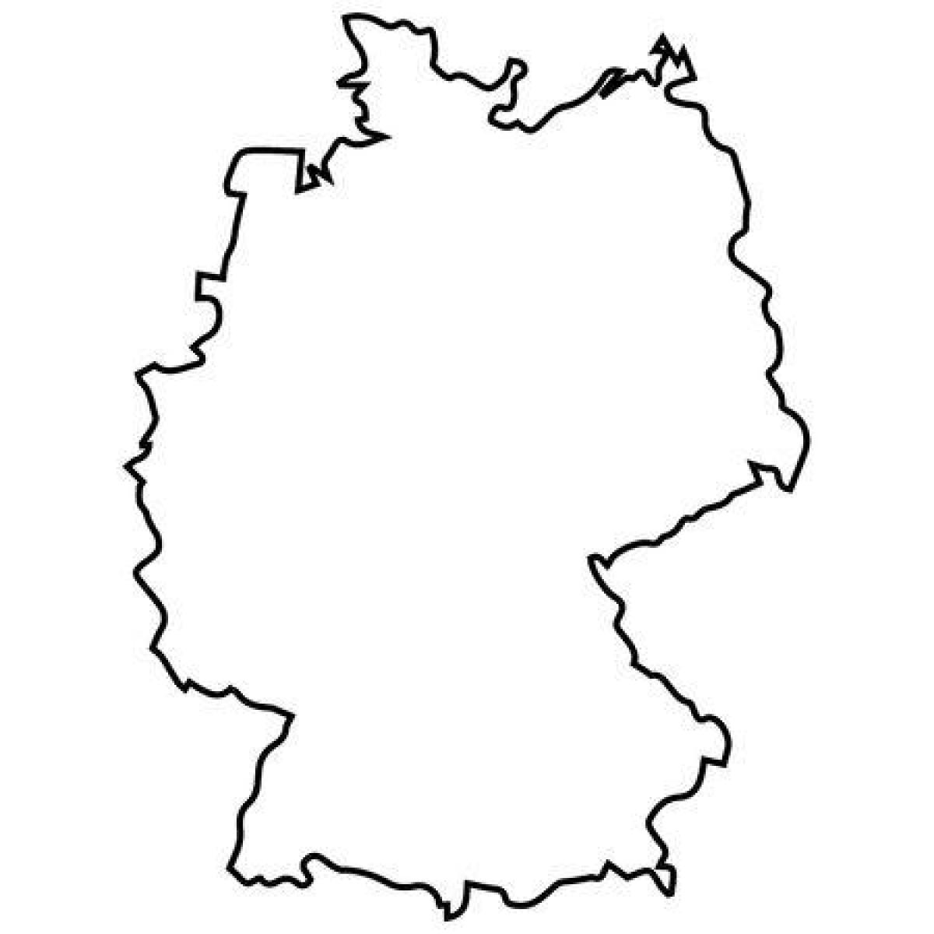

**Task:** Read through the events of the Berlin Crisis and put them into the correct order.

|  |  |
| --- | --- |
|  | Allies decided to airlift supplies from their bases to West Germany into their zones of Berlin. This began on 28th June and was condenamed ‘Operation Plainfare’. |
|  | The crisis increased Eats-West rivalry, confirmed the divisions of Germany and Berlin and led to the creation of NATO. |
|  | Stalin called off the blockade as he had failed to starve the Allies out of Berlin. |
|  | 24th June, 1948-Stalin cut off road, rail and canal traffic to Berlin from the western zone of Germany in an attempt to starve the allies out of West Berlin. |
|  | The air lift reached its peak in April, 1,398 flights landed with nearly 13,000 tonnes of supplies within 24 hours. It supplied clothing, food, oil and building materials. |

**Key terms**

**NATO-** an agreement made between the Western Europe states and the USA that stated that an armed attack against one of them in Europe or North America would be considered an attack against them all. It was a defensive alliance, but one of its main purposes was preventing Soviet expansion.

**Warsaw Pact**- this was a military alliance of eight nations, headed by the USSR. It was designed to counter the threat of NATO.

In the early 1960s, Berlin became an issue again. In August 1961, the now Soviet leader Khrushchev ordered the construction of a wall to separate East Berlin from West Berlin. Khrushchev thought he could bully the new and inexperienced President, Kennedy, so from 5pm on the 27th October to 11am on 28th October, US and Soviet tanks (fully armed) faced each other in a stand-off. After 18 hours, the US tanks pulled back. Kennedy had been forced to back down but was furious with the USSR.

**The Cuban Missile Crisis**

The Cuban Missile Crisis, which took place over a few days in October 1962, brought the superpowers t to the brink of nuclear war. The crisis had spread outside the confines of Europe to the rest of the world.

|  |  |
| --- | --- |
| 16th Oct | Kennedy was told that Khrushchev intended to build missile sites on Cuba. |
| 18th-19th Oct | Kennedy held talks with his closest advisers. The ‘Hawks’ wanted an aggressive policy was the ‘Doves’ favoured a peaceful solution. |
| 20th Oct | Kennedy decided to impose a naval blockade around Cuba to prevent Soviet missiles reaching Cuba. US forces searched any ship suspected of carrying arms or missiles. |
| 21st Oct | Kennedy made a broadcast to the American people informing them of the potential threat and what he intended to do. |
| 23rd Oct | Khrushchev sent a letting to Kennedy saying that Soviet ships would force their way through the blockade. |
| 24th Oct | Khrushchev issued a statement saying that the USSR would use nuclear weapons should there be war. |
| 25th Oct | Kennedy wrote to Khrushchev and asked him to withdraw missiles from Cuba. |
| 26th Oct | Khrushchev replied to Kennedy’s letter saying that he would remove the missiles from Cuba if the USA promised not to invade Cuba and withdrew its missiles from Turkey. |
| 27th Oct | A US spy plane was shot down over Cuba. Robert Kennedy (the President’s brother) agreed a deal with the USSR. The USA would withdraw missiles from Turkey as long as the deal was kept secret. |
| 28th Oct | Khrushchev accepted the deal. |

**Task:** Read through the information in the boxes, using two colours label them as a CAUSE or a CONSEQUENCE of the Cuban Missile Crisis.

|  |  |  |
| --- | --- | --- |
| When Cuba’s new leader (Castro) ejected all US businesses and investment into the country, the US retaliated by refusing to import any more sugar. The USSR swooped in and offered to buy it instead. | Kennedy seemed to have won the war of words. The belief by many was that Khrushchev had backed down, especially as the deal over Turkey wasn’t public knowledge at the time. | The superpowers had almost gone to war, a war that would have destroyed most of the world. There was a relief that the crisis was over and there was a big reduction in tension. A hotline telephone link was established between the White House and the Kremlin. |
| The Partial Test Ban Treaty was signed in August 1963, both the USA and the USSR agreed to stop testing nuclear weapons in the atmosphere. | Soviet technicians began to install ballistic missiles on Cuba. On 14th October, an American spy plane took photographs of Cuba, which showed the Soviet missile launch sites. These could hit almost all US cities so was a major threat to security. | The case for intervention to turn back communism had been shown to be too dangerous. |
| They superpowers had played a game of brinkmanship. This means pushing the situation to the verge of war to encourage or threaten your opponent to back down. | Kennedy authorised an invasion of Cuba by exiles who had left the country. This was known as the Bay of Pigs invasion and it was a disastrous failure due to poor planning and lack of support. It made Cuba even closer to the USSR, and in 1961 Castro announced his conversion to communism. | **KEY** |

**US involvement in Vietnam**

Vietnam was a French colony, but after the defeat of the French in 1954, the US became much more involved in the area. This was because of the containment policy, they wanted to avoid communism spreading to Vietnam. The USA were convinced that if Vietnam fell to communism, its neighbouring countries (Laos and Cambodia) would follow.

|  |  |  |
| --- | --- | --- |
| 1954 | The Geneva Agreement | Vietnam would be divided temporarily into North and South Vietnam. North Vietnam would be led by Ho Chi Minh (communist) and the South would be led by Ngo Dinh Diem. The USA prevented early elections for a new government in July 1956 because they knew the communists would win. |
| 1959 | Vietcong terror campaign | Ho Chi Minh issued orders to the Vietnamh (who became kown as the Vietcong) to begin a terror campaign against the South. |
| 1963 | Overthrow of Diem | In November 1963 Diem, who was corrupt and unpopular, was overthrown and replaced with a series of short-lived weak governments. The Vietcong became more popular in the South. |
| 1963 | Failure of ‘Strategic Hamlet Policy’ | Under Kennedy, the USA tried to reduce communist influence through this policy. It involved moving peasants into fortified villages, guarded by troops. It did not stop the communists and was very unpopular with the peasants. |
| 1964 | Gulf of Tonkin incident | President Johnson wanted more direct military involvement in Vietnam but needed an excuse. On 2nd August 1964, the US destroyer *Maddox* was fired on by the North Vietnamese patrol boats in the Gulf of Tonkin. Johnson was able to use these attacks to persuade Congress to support greater US involvement. |

**Task:** Write a summary on why the US became more involved in Vietnam.

______________________________________________________________________________________________

_______________________________________________________________________________________________

_______________________________________________________________________________________________

_______________________________________________________________________________________________

______________________________________________________________________________________________

______________________________________________________________________________________________

_______________________________________________________________________________________________

The methods used by the US change during the course of the 1960s.

‘Operation Rolling Thunder’

* US bombing campaign of North Vietnam
* Lasted 3.5 years
* Hoped to destroy the Vietcong supply routes to the South
* Encouraged greater support for the war from North Vietnam and did not stop the supplies

Chemical Warfare

* ‘Agent Orange’ was a highly toxic weedkiller used to destroy the jungle- used 82 million tonnes of this
* Napalm was a type of bomb that exploded and then showered the surrounding area with a burning petroleum jelly- stick to the skin and burns at a temperature of 800 degrees centigrade

‘Search and Destroy’

* Used helicopters
* Descend on a village suspected of helping the Vietcong forces and destroy it
* Called these attacks ‘Zippo’
* Would usually only kill a handful of Vietcong soldiers, but a lot of inexperienced US soldiers would walk into traps
* Bad information meant that innocent villages were destroyed
* Civilian casualties were often high
* Made the US very unpopular, especially with the South Vietnam peasants who were more likely to support the Vietcong

**Task:** Read through the reasons for US defeat, decided whether it is the US weaknesses OR strengths of the communists.

|  |  |  |
| --- | --- | --- |
| **The Tet Offensive**- 31st January the Vietcong launched a massive attack on over 100 cities in South Vietnam, showed that they could strike at the heart of US territory, which destroyed US morale and damaged public support. | **Fighting for a cause-** they were fighting for communism and the reunification of Vietnam. They refused to surrender and were prepared to take heavy casualties. | **Failure of US tactics-** failed to develop effective responses to the Vietcong e.g. ‘search and destroy’ and chemical warfare encouraged greater peasant support for the Vietcong. |
| **Support from the South Vietnamese-** some believed in communisms and reunification, their support made the Vietcong’s tactics much more effective | **Opposition at home-** this was because of a failure to achieve a quick victory, over 58,000 casualties and televised pictures showing the horrors of the war. | **Support from the USSR and China-** both of these countries supported the reunification of Vietnam under the communist North, they supplied rockets, tanks and fighter planes. |
| **The US troops-** many were too young and inexperienced and many didn’t understand why they were fighting. This led to a fall in morale, some took to drug-taking and brutal behaviour e.g. My Lai massacre where US troops murdered 347 men, women and children. | **The tunnels**- communist forces dug deep tunnels and used them as air-raid shelters. They sometimes acted as death traps for US forces. | **Effective guerrilla tactics-** fought a ‘low-tech’ war that reduced the effectiveness of the US ‘high-tech’ tactics. These methods were well-suited to the jungle terrain. |

**Task:** Explain what caused the US to lose the Vietnam War, US weaknesses or the strengths of the communists. (You own opinion).

______________________________________________________________________________________________

_______________________________________________________________________________________________

_______________________________________________________________________________________________

_______________________________________________________________________________________________

______________________________________________________________________________________________

______________________________________________________________________________________________

_______________________________________________________________________________________________

_______________________________________________________________________________________________

By 1969, more than _______________ members of the US army had been killed in the war. This meant that President _____________ who was elected because of his promise to withdraw troops from ________________ had to unveil his plans on how to do this. His idea was to replace ______________ with South Vietnamese troops, but they were no match for the communist forces.

For four years there was no real ________________ in peace talks. Each side argued over small issues e.g. the size of the table, where they would sit and who would be involved. The South _________________ President, Thieu didn’t want the South Vietnamese communists at the meetings because that would have made the ________________ more legitimate. However, they were granted a seat.

A turning point came when Nixon visited __________ in 1972. The Chinese encouraged more cooperation from the government in North ______________. On 23rd January a _______________ was signed, and four days later a formal peace treaty came. The US promised to ________________ troops and the Vietcong was allowed to hold on to all the captured areas of __________ Vietnam. Within ____________ the Vietcong had taken control of the whole of Vietnam and achieved ____________________. The US had failed to stop the spread of ___________________.

communism

reunification

China

US troops

Vietcong

progress

South

Nixon

withdraw

Vietnam

Vietnamese

36,000

two years

Vietnam

ceasefire

**Task:** Rank the following impacts of the Vietnam War from 1-6 showing how important they were.

|  |  |
| --- | --- |
|  | The war was very expensive. It cost the taxpayer under half a billion dollars, but within four years this had grown to $26.5 billion because of interest. This was one of the main reasons for the budget deficit and rising inflation. |
|  | The war made President Johnson very unpopular, which encouraged him not to go for re-election. |
|  | The policy of containment had failed, which had shown that not even the US could stop the spread of communism. Vietnam had become communist, but because of US aggression even some of it neighbours had more support for communism. |
|  | It was a propaganda failure because the US were shown to be supporting a corrupt government in South Vietnam. It also exposed the atrocities of the US soldiers and the use of chemical weapons. This damaged the reputation of the USA massively. |
|  | The failure of the war encourage Nixon to try different strategies. He decided to establish closer relations with China and entered a period of détente. |
|  | The Nixon Doctrine stated that the USA expected its allies to take care of their own military defence. the Vietnam War was the first one the US had lost so they became reluctant to take part in any others. |

**Task:** Explain your reasons for your top choice.

______________________________________________________________________________________________

_______________________________________________________________________________________________

_______________________________________________________________________________________________

**Part VII - The Search for World Peace Since 1970**

**Détente and attempts to limit arms**

**Task:** Read the reasons for détente below, for each decide whether it is the USA, USSR or both superpowers.

|  |  |  |
| --- | --- | --- |
| The threat of nuclear war had a sobering effect on all concerned. The Test Ban Treaty also helped ease tensions. | The Soviet invasion of Czechoslovakia in 1968 led to the Brezhnev Doctrine. This said that the USSR would put down any attempt to suppress the Communist control. This alarmed the US, so it was clear that discussions between the two superpowers needed to take place. | The USA and the USSR were keen to discuss arms limitations as it would help them limit their spending on defence. |
| US involvement in Vietnam had not gone well and by 1968, Nixon was keen to end the war. The US hoped that if they increased trade and decreased military spending the Soviets would encourage the North Vietnamese to negotiate a favourable treaty to end the war. | The phone line connecting the White House to the Kremlin had helped to improve the speed of communications between the two superpowers. | Nixon had visited China and Brezhnev (Soviet leader) did not want them to form an alliance. The Soviet leader was keen to gain access to US technology and further their sales of grain. |

**Détente in action**

**Key terms**

**SALT-** Strategic Arms Limitation Treaty

**Task:** Match the agreement to the correct description.

|  |  |  |
| --- | --- | --- |
| SALT I Agreement, 1972 |  | Imposed limits on the nuclear power of the USA and USSR. Agreed not to produce any more ballistic missiles and to limit the use of submarines carrying nuclear weapons. |
| Helsinki Agreement, 1975 |  | Two leaders agreed to develop mutually beneficial cooperation in commercial, economic, scientific, technical and cultural fields. |
| SALT II Agreement, 1979 |  | A limit of 2,400 strategic nuclear delivery vehicles and a ban on the construction of new land based intercontinental ballistic missiles. |

**Changing relations with China**There were a number of reasons for improved relations between the USA and China…

* Relations between the USSR and China had worsened in the late 1960s because the Chinese did not agree with the Soviet Union’s invasion of Czechoslovakia. President Nixon saw an opportunity to exploit this split between the two communist powers.
* Nixon also hoped that better relations with China might help to end the war in Vietnam as the Chinese were close allies with the Northern Vietnamese.

**Key terms**

**Trade embargo-** when a government bans trade with another country.

**Task:** Put the following events in the correct order to show ‘Ping-Pong Diplomacy’…

|  |  |
| --- | --- |
|  | The friendly display of good will was shown in all the newspapers and the US ping-pong team became the first group of US citizens to be permitted to visit China since 1949. |
|  | Richard Nixon became the first US President to visit China. This helped normalise relations between the two countries and helped to reduce tensions in Vietnam. |
|  | The Chinese ping-pong tem formally invited the US team to pay in their country on an all-expenses paid trip(1971). American player, Glen Cowan, missed the bus after practice and was offered a ride by Chinese player, Zhuang Zedong. |
|  | 14th April 1971, the US government lifted a trade embargo with China that had lasted over 20 years. This lead to a meeting between the two country’s leaders, Mao Zedong and Richard Nixon. |

**Changing relations with the USSR**

**Task:** Complete the gap fill below to find out about Soviet involvement in Afghanistan…

On 27th April _________, a communist party overthrew the government of ___________________. The country then became known as the Democratic ______________ of Afghanistan. During its first ________________ the new government imposed a lot of communist _____________, e.g. intellectuals and elite Muslim officials were imprisoned, tortured or murdered. In September 1979, the Deputy ____________________________ seized power, but the anti-Muslim policies still continued, which meant there was still a lot of _________________. Thousands of Afghan-Muslims joined the ____________________, which was a guerrilla movement that wanted to overthrow the communist government. The Afghan-Muslims declared war on the supporters of the communist government and claimed that it was a ‘holy war’. The leader of the USSR, _____________________ was concerned about the growing power of the Muslims and wanted to show them that the USSR was not going to change the way they do things. Between the ________________________ and 1st January 1980, more than 50,000 ______________ troops were sent to Afghanistan to restore order and protect the communist government.

reforms

mujahideen

Soviet

25th December 1979

Bruzhnev

instability

Prime Minister

1978

Republic

Soviet

Afghanistan

18 months

The USA thought that a Soviet-occupied Afghanistan would threaten India and Pakistan and they were concerned that if Soviet influence grew in this area, the they would have control of most of the West’s oil supplies.

President Carter took a firm approach with the USSR over the invasion. This was because he was under a lot of pressure after his failure to solve the hostage situation in Iran quickly (more on that later). He also believed that it would improved relations with China, who also opposed the invasion.

* The Carter Doctrine stated that the USA would use military force if necessary to defend national interests in the Persian Gulf region. It also promised US military aid to all the countries bordering Afghanistan.
* Carter asked the Senate to delay passing the SALT II treaty.
* The USA cancelled all shipments of grain to the USSR, and US companies were forbidden to sell high-tech goods there e.g. computers and oil-drilling equipment.
* Carter pressured the US Olympic Committee to boycott the 1980 Moscow Olympic Games, 61 other countries followed him in this.

**Task:** Which of Carter’s policies do you think would have been the most successful? *Explain reasons for your answer…*

______________________________________________________________________________________________

_______________________________________________________________________________________________

_______________________________________________________________________________________________

_______________________________________________________________________________________________

______________________________________________________________________________________________

______________________________________________________________________________________________

_______________________________________________________________________________________________

**Reagan and the ‘Second Cold War’**

Reagan defeated Carter in the 1980 presidential election and he believed in taking a far tougher approach to relations with the USSR. He made it clear that he had no interest in détente and was prepared to confront the USSR whenever possible, he even called them an ‘evil empire’ during a speech to the British House of Commons in 1982. He was determined to win the Cold War and believed he could push the USSR to disarm using his new Strategic Defence Initiative (SDI).

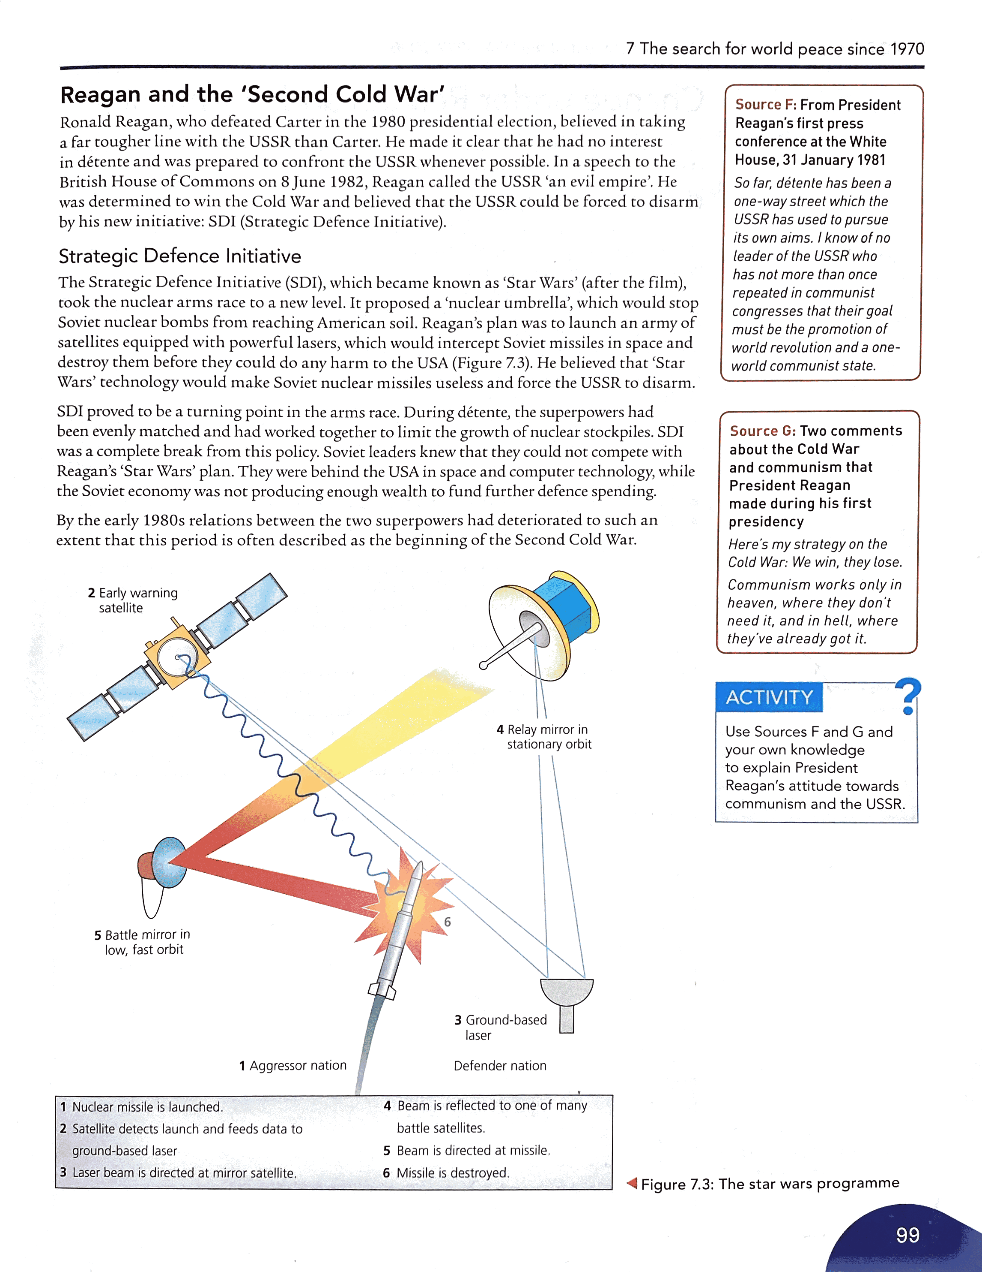

The SDI became known as ‘Star Wars’ after the film and it took the nuclear arms race to a whole new level. It proposed a ‘nuclear umbrella’ that would stop Soviet nuclear bombs from reaching American soil

**Task**: Use the diagram to explain how the SDI worked…

______________________________________________________________________________________________

_______________________________________________________________________________________________

_______________________________________________________________________________________________

_______________________________________________________________________________________________

______________________________________________________________________________________________

______________________________________________________________________________________________

_______________________________________________________________________________________________

SDI proved to be a turning point in the arms race because before the two superpowers had been evenly matched. Soviet leaders knew that they could not compete with Reagan’s ‘Star Wars’ plan. They were behind the USA in space and computer technology and the Soviet economy was not producing enough to allow for further spending on the defence budget. By the 1980s, relations between the two superpowers had deteriorated that much that the period became known as the Second Cold War.

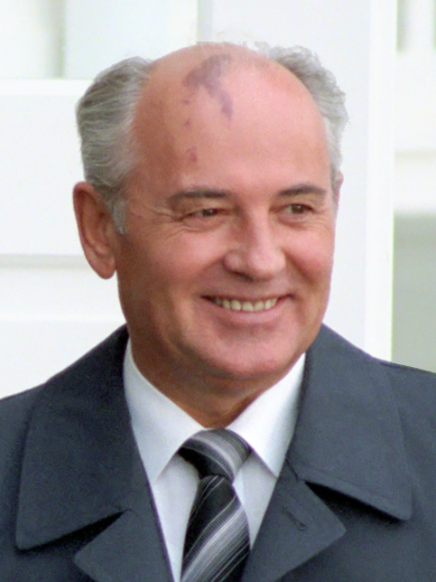**Change under Reagan and Gorbachev**

Gorbachev was the last leader of the USSR, who served from 1985 until 1991. He oversaw the end of the Cold War, the fall of the Berlin Wall and the end of communism in the USSR. Gorbachev recognised that communism in the USSR faced many problems e.g. the economy was not very efficient.

While most Americans experienced a high standard of living in the 1980s, everyday life in the USSR was dominated by shortages. This meant that many Soviet people lost faith in the communist regime.

Gorbachev introduced three strategies to change relations with the USA…

1. Introduced reforms in the Communist Party e.g. made the economy more efficient (*perestroika*) and relaxed censorship of the press (*glasnost*).
2. Ended the arms race with the US and signed arms reduction agreements.
3. Stopped Soviet interference in eastern Europe e.g. Poland & Czechoslovakia.

**Task:** Which of these three strategies would have been the most difficult to achieve e.g. relaxing censorship laws would mean people could be more critical of Gorbachev, which wouldn’t strengthen his position.

______________________________________________________________________________________________

_______________________________________________________________________________________________

_______________________________________________________________________________________________

_______________________________________________________________________________________________

______________________________________________________________________________________________

It became clear that Gorbachev was dedicated to changing relations with the west and the USA. A summit meeting between Gorbachev and Reagan was held in Geneva over two days in November 1985. Although nothing was decided, both leaders promised to meet again in the near future and many people said it was clear that the two men got on.

The second summit meeting in 1986 failed to reach agreements on arms limitations again, but a third one in December 1987 was more successful. At the third meeting, the two leaders signed the Immediate Nuclear Forces (INF) Treaty. This agreed to eliminate nuclear and conventional ground-launched ballistic and cruise missiles with ranges of 500-5,000km. By the deadline, a total of 2,692 weapons had been destroyed- 846 by the USA and 1,846 by the USSR.

After signing the INF Treaty, the final summit meeting was held in Moscow May 1988. A lot of the west had been taken over by ‘Gorbymania’, it was as if Gorbachev had become a pop star. At the Moscow summit there were more arms control talks, which led to the Conventional Forces in Europe (CFE) Treaty, which was signed by NATO and Warsaw Pact representatives in November 1990. This agreement reduced the number of tanks, missiles and aircraft held by the signatory states.

The new US President, George Bush Snr continued good relations with Gorbachev. Together, they announced the Cold War to be over in Malta, 1989. The two superpowers went on to act closely and on the direction of the United Nations.

At the Washington summit of 31st May- 3rd June 1990, Bush and Gorbachev discussed Strategic Arms Limitation (START) and finally signed the Treaty for the Reduction and Limitation of Strategic Arms (START 1) on 31st July 1991. This called for both sides to reduce their strategic nuclear arms over the next seven years. Bush and Gorbachev signed the treaty with pens made from scrapped missiles.

**Task:** Read through the information above and highlight each international agreement made between the two powers along with the date it was signed.

**Task:** Create a timeline showing the key developments in relations between the USA and the USSR (back page of booklet).

**Challenge:** Colour code these developments, depending on whether they are positive or negative.

**The fall of Communism and the end of the Cold War**

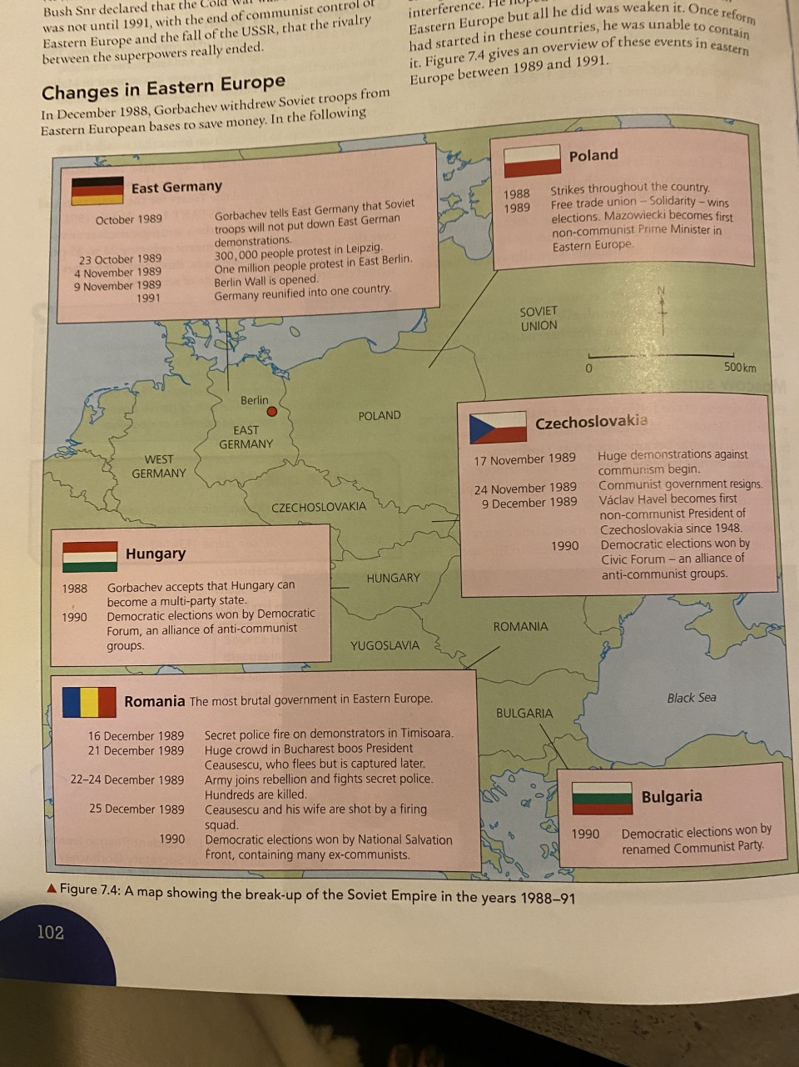Map showing the break-up of the Soviet Empire in the years 1988-91.

On 9th November 1989, the East German government announced the opening of the border crossings into West Germany. The people began to dismantle the Berlin Wall and within a few days, 1 million people had been to see relatives and experience life in West Germany. The two halves were formally reunited in October 1990.

**Task:** Put the following events in order to show the collapse of the USSR…

|  |  |
| --- | --- |
|  | Further demands for independence from within the USSR came. |
|  | The attempted revolution failed and Gorbachev was restored as leader, but he had lost his authority. |
|  | In 1990, the Baltic states of Estonia, Latvia and Lithuania declared themselves independent. This was accepted by Moscow in 1991. |
|  | August 1991, there was an attempted revolution against Gorbachev’s government. |
|  | Gorbachev resigned in December 1991 and the USSR was split into several independent states. |
|  | The fall of the USSR finally ended the rivalry between communism in the East and capitalism in the West, there was only one superpower left. |

**US involvement in Iran, Iraq and the Gulf War**

IRAN

The USA’s closest ally here was the Shah who had been trying to modernise Iran through rapid industrialisation and the emancipation of women. However, the Shah was forced to abdicate in January 1979, which unsettled the whole region.

WHY DID THIS WORRY THE US?

Oil interests in the Gulf area and the Middle East, also the new religious leader of Iran called the USA the ‘Great Satan’ and was determined to destroy all western influences.

IRANIAN HOSTAGES

On 4th November the US Embassy in Iran was taken over by militant Iranian students, they took 66 Americans as hostages. To get the hostages back, the Ayatollah Khomeini demanded that the USA agree to the surrender of the previous leader (the Shah) who at the time was receiving medical treatment in New York.

* The government refused to hand over the Shaha
* They suspended oil imports
* They threatened military action if the hostages were not released
* The Ayatollah refused to budge and threatened to put some of the hostages on trial for spying on Iran
* A rescue mission went horrible wrong in April 1980 when a helicopter crashed killing 8 servicemen
* Carter lost popularity

After the death of the Shah in July 1980, negotiations for the release of the hostages continued. Twenty minutes after Reagan was sworn in as President the American hostages were released after spending 444 days in captivity.

THE GULF WAR, 1990-1

**Task:** Complete the gap fill below…

On 2nd August, the leader of Iraq, ________________________, ordered the invasion of Kuwait. This was one of the leading _________ producing countries in the Middle East. Saddam invaded for a number of reasons…

* Iraq had a lot of __________from the war with Iran, Saddam saw __________________ as a rich prize
* He claimed that Kuwait was historically part of Iraq, even though it had been a separate territory since _______
* Saddam didn’t expect the _______ to use its military power to support ____________ because they had been supporting him with the war against the Iranian regime. He also thought this because the USA didn’t intervene when he _________ crushed a rebellion of the Kurds in the _______ of Iraq.

President _______ Snr, took the lead in pressing for action against the Iraqis in Kuwait. He used the argument that it was clearly aggression against a ______________ state, but really he wanted to _____________ the USA’s oil interests.

The ______________ Nations imposed harsh sanctions on Iraq and then the USA, Britain and other states sent forces to Saudi Arabia. This was called Operation ___________________________, which was designed to defend Saudi Arabia and its vast oil ___________ from possible Iraqi attack whilst pushing Iraqi forces out of _______________.

Kuwait

oil

debts

protect

reserves

Saddam Hussein

Kuwait

1899

Desert Shield

smaller

Kuwait

USA

north

United

brutally

Bush

The offensive against Iraq was launched on 16th January 1991, the attack to liberate Kuwait was launched on 23rd February and by 27th February Kuwait City had been taken over by USA troops and a ceasefire had been issued.

Saddam was allowed to withdraw with much of his army intact even though he was at the mercy of the allies. Bush allowed this to happen because…

* He was afraid that if the slaughter continued, the allies would lose support from the other Arab nations
* It was widely expected outside Iraq that Saddam Hussein would soon be overthrown, especially after his humiliating defeat

Immediately after this victory, Bush’s reputation stood high. However, overtime he began to be criticised for allowing Saddam Hussein to remain in power and not using the victory to the American’s advantage enough. Saddam had enough troops to remain in power and brutally suppress rebellions by Muslims in the south and the Kurds in the north.