**Germany in Transition, 1919-39**

**Part I - The Impact of the First World War**

The Weimar Constitution

**Key terms**

**Constitution-** the basic laws of a nation/state e.g. how it is governed.

**Proportional Representation-** a way of counting votes where 60,000 votes equals one seat in the Reichstag

**Task:** Match the following elements of the Weimar Constitution to the correct description.

|  |  |  |
| --- | --- | --- |
| Article 48 |  | Governing body that was elected every four years. They could make laws and control taxation. |
| Chancellor |  | Elected every seven years. Was Supreme Commander of the army, could dismiss the Reichstag and call new elections. |
| Reichstag |  | President could suspend the Constitution in an emergency. He could make laws without the use of the Reichstag. |
| President |  | Men and women over the age of 20 years. |
| Electorate (voters) |  | Chosen by the President. Had to have support of a majority of the Reichstag. |

**Task:** Complete the gap fill below to identify the key elements of the Weimar Constitution.

STRENGTHS of the Weimar Constitution:

* It was very _____________. Men and women had the vote at the age of 20 years, which was even more democratic than _____________ where the age for men was 21 years and for women, 30 years.
* The ______________ had to have the support of most of the politicians in the _______________.
* Voting by ___________________________________ meant that the number of seats each party had in the Reichstag was based on the number of votes they got. For example, if a party won 10% of the votes the would win ________ of the seats in the Reichstag.

WEAKNESSES of the Weimar Constitution:

* ________________ was not very democratic because it allowed the President to abandon the constitution and overrule the _____________.
* Proportional representation meant that lots of smaller parties gained seats in the Reichstag making it very difficult to get a _____________. As a result, parties had to form ______________ and these often failed because of various disagreements.

Coalitions

Britain

Reichstag

majority

Reichstag

10%

Democratic

Proportional representation

Chancellor

Article 48

The Treaty of Versailles

**Key terms**

**Reparations-** war damages to be paid by Germany

**Diktat-** dictated peace i.e. the Treaty of Versailles was forced on Germany because they were not allowed in the negotiations.

For most Germans, the Treaty of Versailles was a dictated peace- *diktat*. The Weimar government was blamed for this even though the initially rejected the treaty. Many people believed that the German army had not been defeated by the Allies, but forced to surrender by the new government. The army had been ‘stabbed in the back’ by the politicians who signed the armistice- these politicians became known as ‘November criminals’.

**Task:** Use three colours to categorise the following terms of the Treaty of Versailles.

**KEY**

Territorial terms

Military terms

Financial terms

* The army could not exceed 100,000 soldiers
* Alsace-Lorraine was returned to France
* Reparations were fixed at £6.6 billion
* Rhineland was demilitarised
* No union with Austria (Aschluss)
* No submarines
* All colonies to be given to the Allied Powers
* West Prussia given to Poland
* Coal to be mined in the Saar by France
* 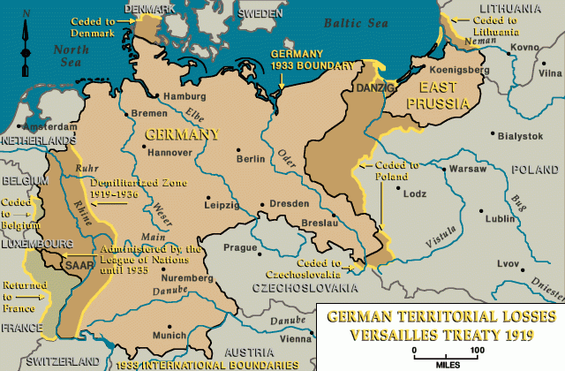No tanks, armoured cars or heavy military permitted

Picture 1. The territory lost by Germany as part of the Treaty of Versailles.

Political instability

The Weimar government was unpopular among many Germans, especially communists, socialists, nationalists, army leaders and those who helped govern Germany before. The Weimar Republic faced many threats from the left and the right, including several uprisings that threatened the government’s existence.

Some Germans were hopeful that there would be a Communist revolution in Germany, just like in Russia. Soldiers, sailors and workers set up councils in October and November 1918.

This fear encouraged the German government to make a deal with the new army leader, General Groener. They agreed that the army would support the new government against revolution and the government would help support the supply of the army. Some Germans thought that the Weimar’s dependency on the army made them weak.

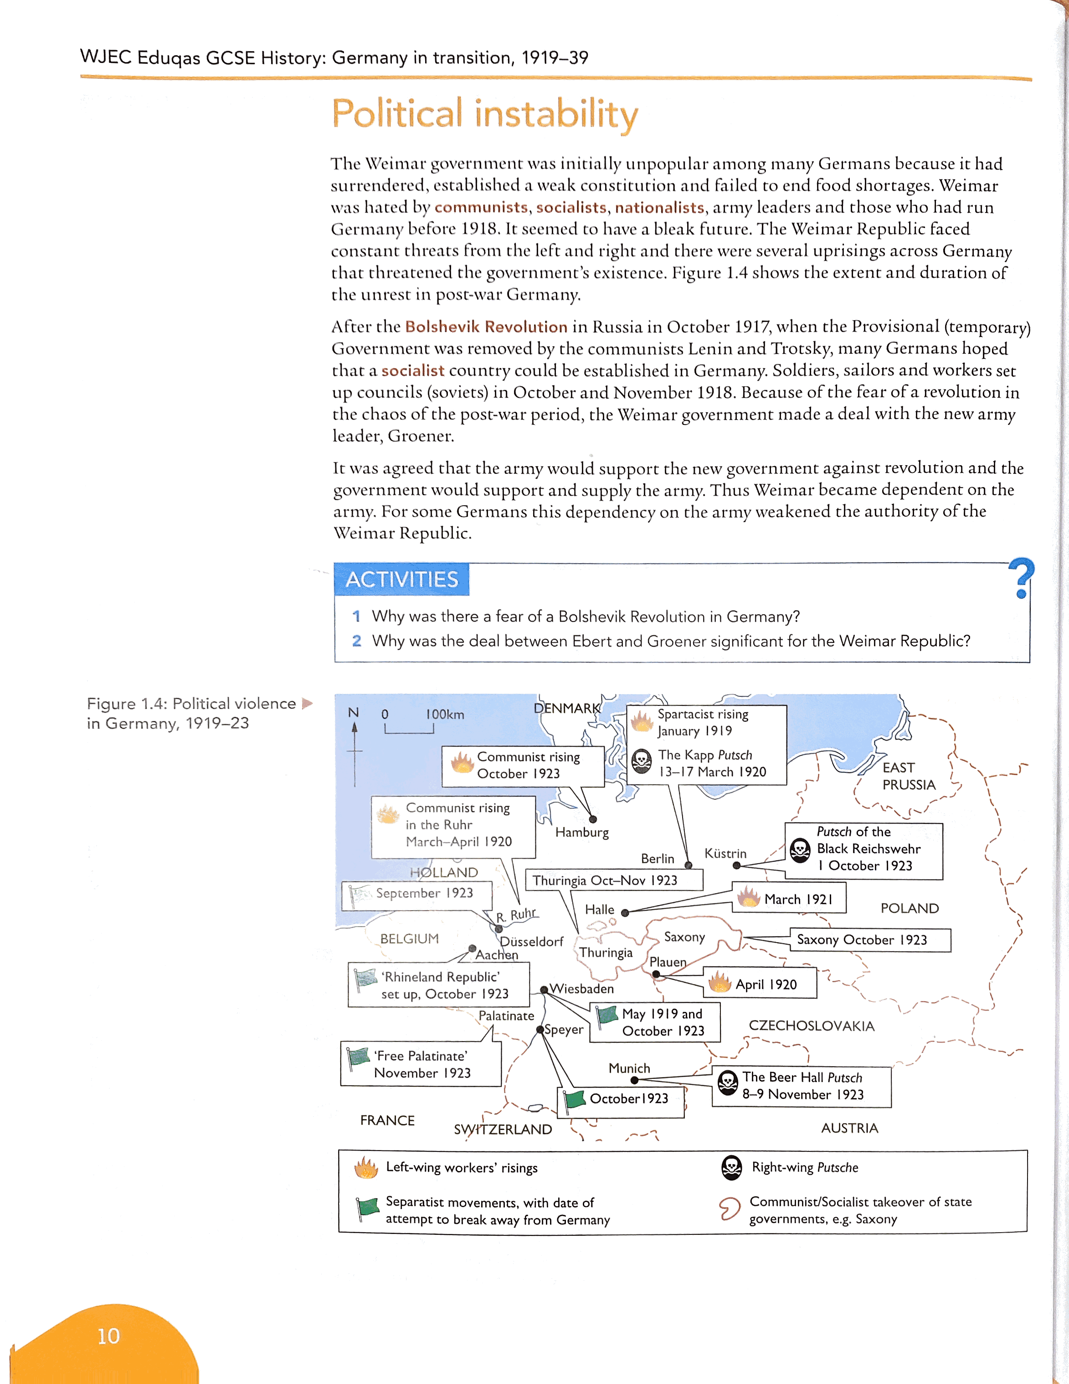

SPARTACIST UPRISING

Who? Rosa Luxemburg, Karl Liebknecht, the Spartacist League (communists)

Where? Berlin, Germany

When? 6th January 1919

Why? Wanted to overthrow the Weimar government and start a Communist revolution

Events- after some protests, the Spartacists declared a general strike on 6th January, over 100,000 workers were involved in the action and rebellion. During this strike, the Spartacists seized key government buildings and telegraph offices.

End- the Weimar government found the revolt difficult to handle and asked the Freikorps (ex-soldiers) to put down the rebellion. They managed to do this by 13th January. Luxemburg and Liebknecht were arrested and killed.

KAPP PUTSCH

Who? Freikorps and Wolfgang Kapp

Where? Berlin, Germany

When? March 1920

Why? The Freikorps (ex-soldiers) were angry because of the restrictions the Weimar government had placed on them as part of the Treaty of Versailles

Events- Kapp successfully seized Berlin on 13th March, the Weimar government moved to Dresden and then Stuttgart. The Weimar government had asked the army to help stop the rebellion, but they refused to fire on fellow soldiers.

End- President Ebert called on the people of Berlin not to support the Kapp Putsch and asked them to go on strike. This meant that the rebellion had little support and it collapsed.

**Task**: Which do you think was a bigger threat to the Weimar government, the Spartacist Uprising or the Kapp Putsch? *Explain your answer*

________________________________________________________________________________________________________________________________________________________________________________________________________________________________________________________________________________________________________________________________________________________________________________________________________________________________________________________________________________________________________________________________________________________________________________________________________________________________________________________________________________________________________________________________________________________________________________________

Events in the Ruhr and hyperinflation

**Key terms**

**Hyperinflation-** extremely high inflation, where the value of money plummets and becomes worthless

**Passive resistance**- opposition to a government without using violence

During the First World War, Germany had borrowed lots of money. This meant that when the reparations were announced at £6.6 billion, the Weimar government claimed they could not afford it. They had also lost a lot of industrial land as party of the Treaty of Versailles, this made the problem much worse. To solve the problem, the Weimar government started to print more money so that they could pay France. The value of Germany currency started to fall rapidly and when Germany defaulted on one of their payments, the French occupied the Ruhr. The Ruhr was part of the Rhineland, which was an area where the German army were not allowed to go, this meant the Germans could not stop France from occupying it.

**Task:** Complete the gap fill below to find out about French occupation of the Ruhr.

French occupation was met with ______________________________________. This was when the German workers went on strike as a protest against the invasion. A number of these strikers were shot by French troops. The invasion united people in their _______________ of French and Belgian troops. The strikers became heroes as they were standing up to the humiliating terms of the ___________________________________. The German backed the workers by printing more _______________ to pay their wages. With people not working, Germany was producing even less ___________, which meant even less money. The extra strike money plus the collapse in production turned inflation into _________________________.

goods

Treaty of Versailles

money

hyperinflation

hatred

Exam Style Question

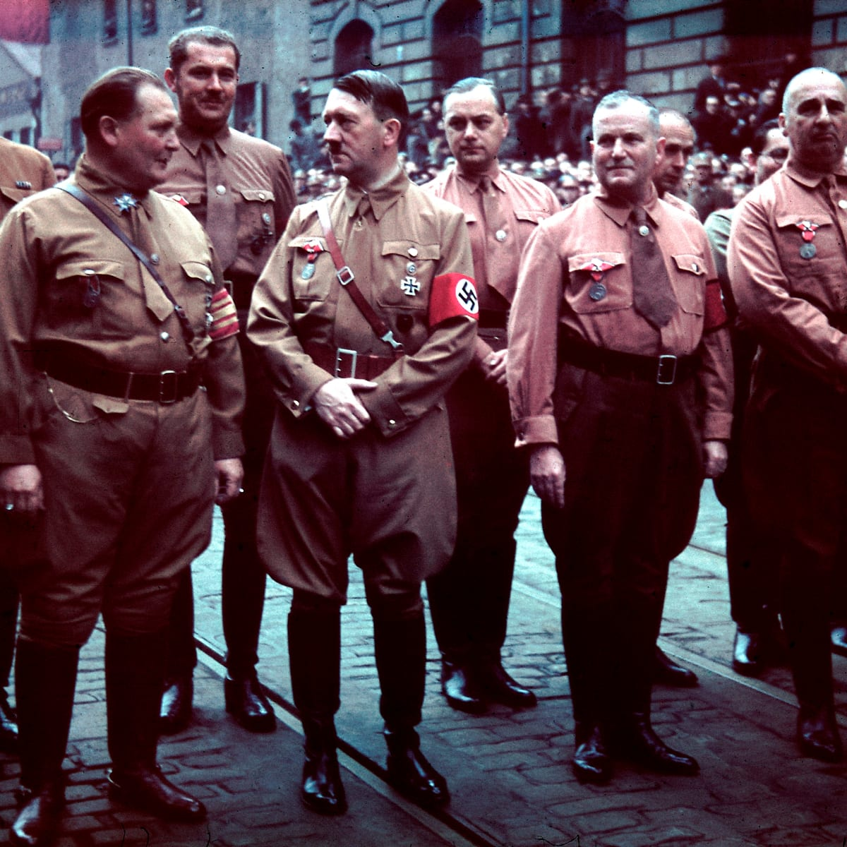 **Source A**: Hitler and his fellow Nazis marching through Munich in 1923

Use source A and your own knowledge to describe the events of the Munich Putsch (5 marks)

__________________________________________________________________________________________________________________________________________________________________________________________________________________________________________________________________________________________________________________________________________________________________________________________________________________________________________________________________________________________________________________________________________________________________________________________________________________________________________________________________________________________________________________________________________________________________________________________________________________________________________________________________________________________________________________________________________________________________________________________________________________________________________________________________________________________________________________________________________________________________________________________________________________________________________________________________________________________________________________________________________________________________________________

Q2: What is the purpose of source D? [8]

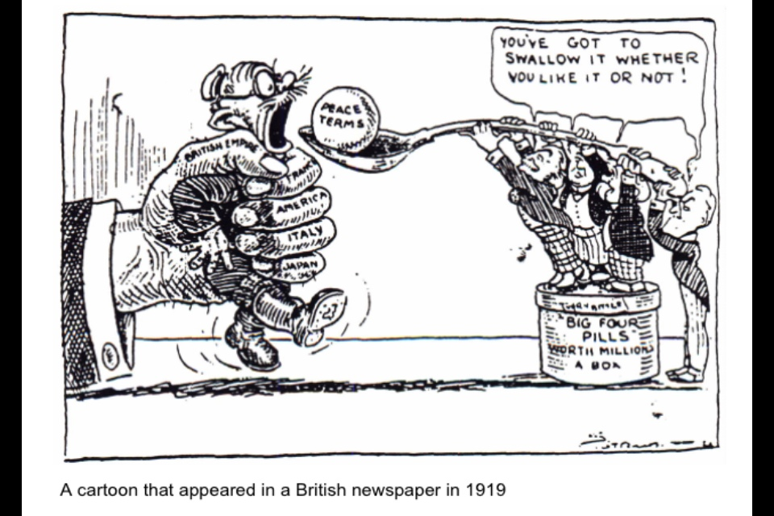

A cartoon by that appeared in a British newspaper in 1919, showing Germany being given the terms of the Treaty of Versailles by Britain, France and the USA.

___________________________________________________________________________________________________________________________________________________________________________________________________________________________________________________________________________________________________________________________________________________________________________________________________________________________________________________________________________________________________________________________________________________________________________________________________________________________________________________________________________________________________________________________________________________________________________________________________________________________________________________________________________________________________________________________________________________________________________________________________________________________________________________________________________________________________________________________________________________________________________________________________________________________________________________________________________________________________________________________________________________________________________________________________________________________________________________________________________________________________________________________________________________________________________________________________________________________________________________________________________________________________________________________________________________________________________________________________________________________________________________________________________________________________

**Part II -** **The Recovery of Weimar**

Recovery from hyperinflation **Task:** Match the following agreements to the correct description.

|  |  |  |
| --- | --- | --- |
| The Dawes Plan |  | Agreed the reparations figure should be reduced from £6.6 billion to £1.85 and that the length of time Germany had to pay would be extended to 59 years. |
| The Young Plan |  | Agreed that Germany and 64 other nations would keep their armies for self-defence only and solve all international disputes through peaceful means. |
| The Locarno Pact |  | Named after the US vice-president, Charles Dawes. Agreed that payments would be made at 1 billion marks for the first year and would increase slowly, US would provide Germany with loans and French troops would evacuate the Ruhr by 1925. |
| The Kellogg-Briand Pact |  | Agreement between Germany, France, Belgium and Italy to jeep existing borders. This started a period of cooperation between Germany, France and Britain. |
| League of Nations |  | An international organisation set up in 1920 to try and maintain peace. Germany was initially left out of this organisation, but was allowed a seat in 1926. This showed Germany’s return as an leading power. |

Political and social developments

|  |  |  |  |
| --- | --- | --- | --- |
|  | **May 1924** | **December 1924** | **May 1928** |
| **Social Democrats (SPD)** | 100 | 131 | 153 |
| **National Party (DNVP)** | 95 | 103 | 73 |
| **Communist Party (KPD** | 62 | 45 | 54 |
| **Nazi Party** | 32 | 14 | 12 |

*Table 1. Election results 1924-8*

**Task:** Use *Table 1* to answer the questions below.

1. What was the most popular party between 1924-8?

_______________________________________________________________________________________________

1. Which party gained the most seats from 1924-8?

_______________________________________________________________________________________________

1. Compare the election results of the two extreme parties (KPD and Nazi Party).

______________________________________________________________________________________________________________________________________________________________________________________________

Stability between 1924-8 was down to the popularity of two leaders, S_________________ and H_______________. Hindenburg had been one of Germany’s war leaders during 1914-8 and he was elected President in 1925, which showed that even the conservative had begun to accept the Weimar Republic.

The period of 1924-9 is described as a ‘golden age’ in the Weimar Republic because of changes in the standard of living, the position of women and culture.

**Task:** Use three colours to categorise the following social changes.

**KEY**

Wages

Housing

Unemployment insurance

* By 1928 there had been an increase in real wages of over 10%- Germany had some of the best paid workers in Europe
* By 1928, homelessness had been reduced by 60%
* The government introduced tax breaks, land grants and low-interest loans to encourages the building of new houses and apartments
* The middle classes didn’t benefit much, they tended to be the ones who lost their savings during the hyperinflation crisis
* Introduced reforms to help war veterans, wives and dependents of the war dead, single mothers and the disabled
* Weimar employed architects and planners to come up with ways to deal with the housing shortages
* Unemployment remained high in professions such as teachers, lawyers and civil servants
* Between 1924-8, more than 2 million new homes were built
* Weimar Republic introduced the Unemployment Insurance Law in 1927, which made workers and employees to make contributions to a national scheme for unemployment welfare
* In April 1928 almost 184,000 middle class workers were unemployed, but almost half of them did not qualify for unemployment benefits from the government
* By 1929, the state was spending 33 times more on housing than it had been in 1913

**Task:** Complete the gap fill to find out about the change in the position of women during Weimar Germany.

In 1919 women over the age of _______ were given the vote. The Weimar constitution also introduced equality in education, allowed women to become ____________________ and gave them equal _________ in many professions. German women had some of the most ____________________ legal rights of any country in Europe.

There were also changes in employment. The most obvious change was the number of women in new areas of employment e.g. _______________, social work, shops, factories and civil service. By 1933, there were ____________ women teachers and 3,000 doctors.

Women also enjoyed much more freedom socially. The went out unescorted, drank and smoked in public. They became very fashion conscious, wearing short _________ and _______________.

pay

20 years

advanced

teachers

100,000

politicians

skirts

makeup

ART

* Weimar artists tried to show everyday life
* They wanted ordinary people to understand the art, so reflected their lives
* This new art was given the name ‘new objectivity’ because the artists wanted to portray society in an objective way
* A famous Weimar artist was George Grosz

ARCHITECTURE

* Bauhaus was the ‘School of Building’ for architects
* They designed lots of things e.g. chairs, houses and cigarette kiosks
* Their approach was very different to pre-war designs- less elaborate and less decorative

CINEMA

* Golden age for cinema e.g. Fritz Lang’s *Metropolis* (thought to be the best film of the decade)
* Futuristic science-fiction film that shows a city where a beautiful and cultured utopia exists above a bleak underworld of mistreated workers

LITERATURE

* Right-wing writers were critical of German democracy and glorified their experiences in WWI e.g. Arthur Möller and Oswald Spengler
* Other writers were anti-war e.g. Erich Remarque and Ludwig Renn, they described the horrors of war

**Task**: To what extent was the period between 1924-9 the ‘golden age’? *You need at least two pieces of evidence for each side.*

|  |  |
| --- | --- |
| **Was a ‘golden age’** | **Was NOT a ‘golden age’** |
|  |  |

What’s your overall opinion? *Explain your answer*

____________________________________________________________________________________________________________________________________________________________________________________________________________________________________________________________________________________________________________________________________________________________________________________________________________________________________________________________________________________________________________________________________________________________________________________________________________________________________________________________________________________________________________________________________________________________________________________________________________________________________________________________________________________________________________________________________________________________________________________________________________________________________________________________________________________________________________________________________________________________________________________

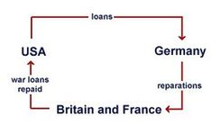

Using the above diagram, describe the changes that happened to Germany economically between 1923 and 1929.

____________________________________________________________________________________________________________________________________________________________________________________________________________________________________________________________________________________________________________________________________________________________________________________________________________________________________________________________________________________________________________________________________________________________________________________________________________________________________________________________________________________________________________________________________________________________________________________________________________________________________________________________________________________________________________________________________________________________________________________________________________________________________________________________________________________________________________________________________________________________________________________

**Part III - The Nazi Rise to Power and the End of the Weimar Republic**

The early Nazi Party

|  |  |
| --- | --- |
| **Point** | **Content** |
| No.1 | The union of all Germans to form a Greater Germany |
| No.2 | The scrapping of the Treaty of Versailles |
| No.4 | Citizenship of the state to be granted only to people of German blood. Therefore no Jew was to be a citizen of the nation. |
| No.6 | The right to vote in elections to be allowed on to German citizens. |
| No.7 | Foreign nationals to be deported if it became impossible to feed the entire population. |
| No.8 | All non-Germans who had entered the country after 1914 to leave. |
| No.13 | The government to nationalise all businesses that had been formed into corporations. |
| No.14 | The government to profit-share in major industries |
| No.17 | An end to all speculation in land and any land needed for communal purposes would be seized. There would be no compensation. |
| No.23 | All newspaper editors and contributors to be German, and non-German papers to appear only with permission of the government. |
| No.24 | Religious freedom for all- providing the views expressed did not threaten or offend German people. |
| No.25 | The creation of a strong central government for the Reich to put the new programme into effect. |

**Task:** Use five colours to categorise the points above. Highlight the point depending on the category it covers: *Treaty of Versailles, race, religion, civil rights and industry*

MUNICH PUTSCH

Who? Adolf Hitler, Nazi Party, von Kahr, von Lossow and von Seisser

Where? Munch, Bavaria, Germany

When? 8th-9th November 1923

Why? Wanted to overthrow the Weimar government and start a Nazi dictatorship- also wanted to increase his fame

Events- Hitler and 600 Nazis seized a beer-hall where von Kahr, von Lossow and von Seisser were holding a meeting. Hitler explained his plan to them and asked for their support, whilst holding them at gunpoint. He promised he had the support of General Ludendorff.

End- von Kahr, von Lossow and von Seisser were allowed to leave the beer-hall and when they left they told the army Hitler’s plans. Hitler continued with his plans and started to march through Munich, but was met by the army- 16 Nazis met them and 4 police were killed. Hitler was arrested two days later and the Nazi party was banned.

Hitler’s trial- Hitler was arrested and tried for treason along with General Ludendorff. The trial gave Hitler nationwide publicity and got him on the front of many German newspapers. He claimed he was ‘not guilt’ and that he was acting in the best interests of Germany. He used his trial as an opportunity to talk about the Treaty of Versailles, the November Criminals and the Jews.

**Task:** Read through the outcomes of the Munich Putsch and decide whether they show it to be a success or failure for Hitler and the Nazis.

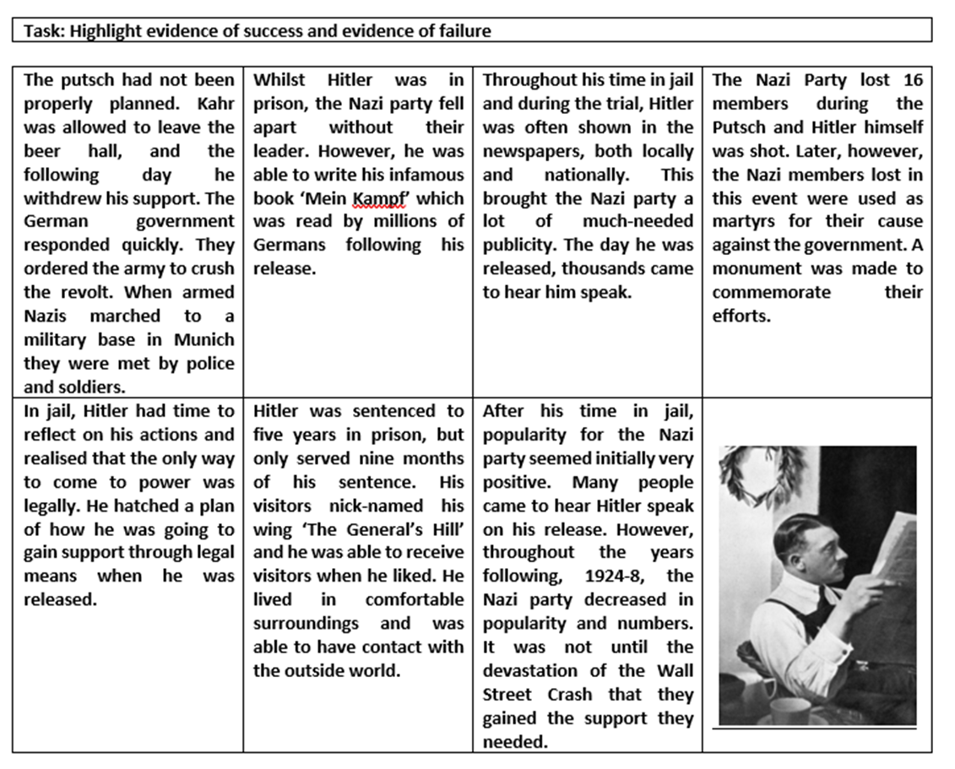**Task:** Complete the gap fill below to find out how Hitler used the Wall Street Crash to gain popularity.

**KEY**

Wages

Housing

Unemployment insurance

The impact of the Depression

Hitler had tried to win the votes of people living in urban areas, but now he wanted to target ___________ voters too. This came at a time when farmers were beginning to experience ________________ problems and found Nazism attractive.

The Nazi Party only had 27,000 members in _________, but by the end of 1928 membership was more than _____________. Hitler had been successful in targeting all classes, but only won ____ seats in the Reichstag elections (1928) when he head 32 seats in 1924. Hitler made further changes in the late 1920s, he made _________________________ Party Propaganda Leader.

The ______________________________ in 1929 created an economic crisis in Germany and unemployment started to _____________. Hitler and the Nazis were in power only _______ years after the crash.

12

rural

economic

Four

Joseph Goebbels

rise

1925

Wall Street Crash

100,000

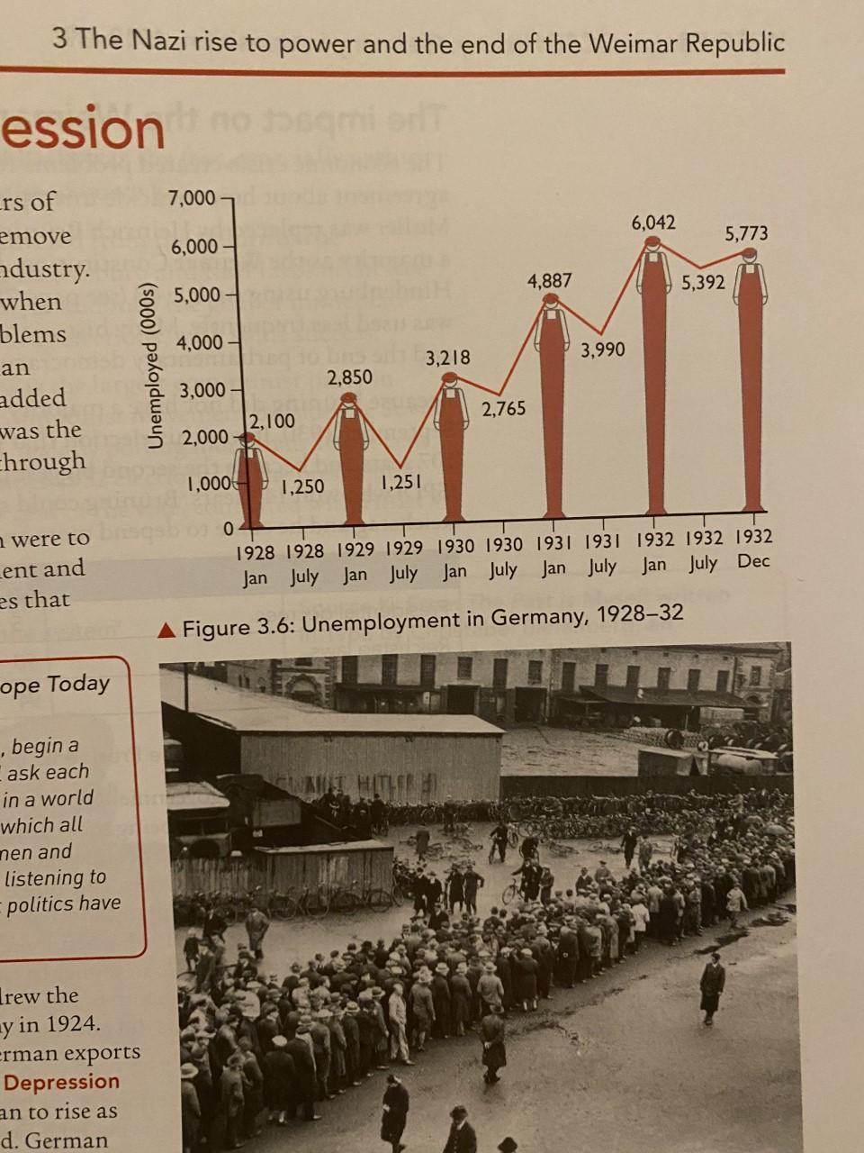

*Table 1. Unemployment in Germany, 1928-32*

**Task:** What can you learn from table 1 about the impact of the Wall Street Crash on Germany? *Try to make at least 3 points.*

_________________________________________________________________________________________________________________________________________________________________________________________________________________________________________________________________________________________________________________________________________________________________________________________________________________________________________________________________________________________________________________________________________________________________________________________________________________________________

The economic crisis created problems for the Weimar government. The new Chancellor, Heinrich Brüning relied on Hindenburg using Article 48- many historians see this as the end of democracy and the Weimar Republic.

Brüning did not have a majority in the Reichstag so he called an election in September 1930. This election gave the Nazis a breakthrough, they won 107 seats and became the second largest party in Germany. Brüning could not rely on having all of his policies accepted by the Reichstag so he kept relying on President Hindenburg.

This lost him a lot of support, especially with the unemployed. The people of Germany were experiencing food shortages again, the third time in the past 16 years- this lead to Brüning’s nickname the ‘hunger chancellor’. The Chancellor was also to blame for foreign investors withdrawing from Germany, this is because some banks had closed down during the crisis. The only advantage of the economic crisis was that reparations had been suspended.

Brüning resigned in May 1932, but the Nazi party had already been successful in regional general elections. Over the next eight months there was more political and economic turmoil, which led to the extremist parties becoming more violent. The depression had unleashed chaos across Germany, resulting in Hitler becoming Chancellor on 30th January 1933.

**Task:** Summarise the following boxes of information into no more than one sentence. This will explain why there was growing support for the Nazi party.

|  |  |
| --- | --- |
| **Reason for growing support** | **One sentence…** |
| **Propaganda**  The Nazis held mass rallies, placed posters in prominent places and displayed banners wherever possible. Joseph Goebbels ensured that the Nazi message was simple and repeated frequently. |  |
| **Success in elections**  Unemployment had hit all classes and so Hitler and the Nazis tried to appeal to all sections of society. The Nazi message was that the Weimar government had caused the economic crisis. |  |
| **The presidential election 1932**  During this election, Hitler stood against Hindenburg. The Nazis used modern technology, for example Hitler was able to speak to as many as 5 cities on the same day, flying from 1 venue to the next. |  |
| **Financial support for the Nazis**  They received funds from leading industrialists (business owners) such as Thyssen, Krupp and Bosch. The industrialists were terrified of the communist threat and were also concerned at the growth of trade union power. |  |
| **The SA and the communists**  In his speeches, Hitler claimed that only he and the Nazis could provide the strong government that Germany needed. The Nazis used their private army, the SA, to provide protection for their meetings, and to disrupt the meetings of their opponents, especially the communists. |  |
| **Hitler’s electoral campaign**  Hitler had developed the art of public speaking in the early days of the NSDAP. His speeches always attracted many people and helped increase the membership of the Nazi Party. He was fully aware that after the Putsch he had to present himself and his party as law abiding and democratic. |  |

Political scheming, 1932-3

**Task:** Put the following events in the correct order to show how Hitler became Chancellor (some have dates to help you).

|  |  |
| --- | --- |
|  | Von Papen was determine to regain power, so he made a deal with Hitler where von Papen would be vice-chancellor to Hitler. |
|  | Even after the November 1932 elections, von Papen (Centre Party) still did not have a majority in the Reichstag. This had caused Hindenburg to lose confidence in him- von Papen resigned and was replaced by von Schleicher. |
|  | Hitler was made Chancellor on 30th January 1933. |
|  | The Nazis won 230 seats in the general election on 31st July. This gave the Nazis the most seats out of any other party, so Hitler demanded to be made Chancellor instead of von Papen- Hindenburg refused this. |
|  | Von Papen managed to convince Hindenburg that Hitler would be able to bring stability as Chancellor because he would control him. |
|  | Von Papen dissolved the Reichstag in September and called for new elections in November. This was because there was no majority and he could not form a coalition. |

**Task:** Colour code the information to show which individual it is about: *Hitler, Hindenburg, von Papen or von Schleicher*.

|  |  |  |
| --- | --- | --- |
| Was a member of the Centre Party. | Succeeded von Papen as Chancellor. | Became the President of the Weimar Republic in 1925. |
| Became Chancellor on 30th January 1933. | Refused to make Hitler Chancellor in 1932. | Fought in the German Army during WWI. |
| Had the most seats in the Reichstag. | Made a deal with Hitler where he would become vice-Chancellor. | Called for a general election in November 1932. |

Q2: What is the purpose of source D? [8]



*A cartoon by that appeared in a British newspaper in 1919, showing Germany being given the terms of the Treaty of Versailles by Britain, France and the USA.*

_________________________________________________________________________________________________________________________________________________________________________________________________________________________________________________________________________________________________________________________________________________________________________________________________________________________________________________________________________________________________________________________________________________________________________________________________________________________________________________________________________________________________________________________________________________________________________________________________________________________________________________________________________________________________________________________________________________________________________________________________________________________________________________________________________________________________________________________________________________________________________________________________________________________________________________________________________________________________________________________________________________________________________________________________________________________________________________________________________________________________________________________________________________________________________________________________________________________________________________________________________________________________________________________________________________________________________________________________________________________________________________________________________________________________________________________________________________________________________________________________________________________________________________________________________________________________________________________________________________________________________________________________________________________________________________________________________________________________________________________________________________________________________________________________________________________________________________________________________________________________________________________________________________________________________________________________________________________________________________________________________________________________________________________________________________________________________________________________________________________________________________________________________________________________________________________________________________________________________________________________________________________________________________________________________________________________________________________________________________________________________________________________________________________________________________________________________________________________________________________________________________________

**Part IV - Consolidation of Power**

The Reichstag Fire **Task:** Complete the gap fill below to find out about the Reichstag Fire.

When Hitler became _________________ in January 1933, his position was not strong. This is because President __________________ hated him and he did not have a majority with the Nationalist Party. Despite this, it was soon clear than Von Papen was not able to ______________ him.

Hitler immediately called for a general _____________ in March 1933, hoping that it would give the Nazis a majority in the ________________. The Nazis used violence and _____________, which caused 70 deaths leading up to the election. Hitler had received large amounts of money from ___________________ to fund his campaign and Joseph _______________ used this money to get the propaganda message across.

A week before the election on the __________________ 1933, the Reichstag building was set on _________. It is not known who started the fire, but the Nazis arrested Marinus ______________________, a Dutch ________________. Hitler and Goebbels saw this as a great opportunity to claim the Communists were trying to attempt a ____________________.

After the Reichstag Fire, Hitler encouraged Hindenburg to sign the ‘Decree for the _____________________ _______________________’. This suspended civil rights and allowed the Nazis to imprison large numbers of their ____________________________________. Socialist and Communist ____________________ were banned.

political opponents

Van der Lubbe

Reichstag

terror

control

Hindenburg

Chancellor

Goebbels

27th February

Communist

take over

election

Protection of People and the State

newspapers

The 1933 election and the Enabling Act

**Key terms**

**Dictatorship-** a form of government where one person has the ultimate power to run the country.

**Censorship-** controlling what speech or information is produced and suppressing anything that is thought to be against the state.

At the March 1933 election, the Nazis won 288 seats. Despite imprisoning many socialist and communists, the Nazis still did not have a majority in the Reichstag. Hitler was disappointed because he needed at least two-thirds of the seats in order to change to constitution.

Hitler’s next step was to pass the **Enabling Act**. This would give him and his government full powers for the next four years and would mean that the Reichstag would become pointless. The act was passed, by devious means.

The **Enabling Act** was passed 23rd March 1933 and was the end of the Weimar Republic and democracy. It quickly led to the suspension of civil liberties (e.g. right to a fair trial), allowed Hitler to censor and control the press, abolition of trade unions and the banning of other political parties. Hitler had created a **dictatorship**.

Hitler managed to pass the **Enabling Act** by…

* Not allowing Communists to vote
* Promising not to interfere in Catholic Schools if members of the Catholic Party voted in favour
* Counted absentees (those that didn’t show up) as present and in favour
* Getting the SA to intimidate members as they went in to vote

**Task:** Use the information above to answer the questions below…

1. Explain why the Enabling Act can be seen as the beginning of the Nazi dictatorship.

________________________________________________________________________________________________________________________________________________________________________________________________________________________________________________________________________________________________________________________________________________________________________________________________________________________________________________________________________________________________________________________________________________________________________________________________________________________________________________________________________________________________________________________________________________________________________________________

1. How important was the Enabling Act in increasing Hitler’s power?

_______________________________________________________________________________________________

_______________________________________________________________________________________________

_______________________________________________________________________________________________

_______________________________________________________________________________________________

_______________________________________________________________________________________________

_______________________________________________________________________________________________

_______________________________________________________________________________________________

_______________________________________________________________________________________________

_______________________________________________________________________________________________

**Task:** Match the following way Hitler removed his opposition to the correct description

|  |  |  |
| --- | --- | --- |
| Trade unions |  | The eighteen state parliaments were abolished in January 1934 and Hitler decided that they would be run by Reich governors instead. This was the first time the country had been centralised since 1871. |
| Political parties |  | The Labour Front (DAF) was set up to replace this. The DAF decided on workers’ wages and every worker had to have a logbook with their employment history recorded. Strikes were outlawed, anyone who took part in them were sent to concentration camps. |
| Control of state government (Länder) |  | The Communist Party had been banned and its property was confiscated. On 10th May the SPD had its headquarters and property seized. The remaining political parties disbanded themselves by the beginning of July. |

The Night of the Long Knives

This was the purging of Hitler’s military and political rivals in the SA. Hitler wanted to do this because he needed to win over the army, but he also saw the SA as a threat during his chancellorship. The SA had been a key part in the growth of the Nazis and by 1933 they were well-known across Germany. Most of the SA were working class people who favoured the socialist views of the Nazi programme. They were hoping that Hitler would introduce reforms to help the workers.

Ernst Röhm, the leader of the SA, had different ideas to Hitler. He wanted to incorporate the army into the SA and wanted Hitler to abandon his close relations with the industrialists (the people who funding his campaigns). Rohm wanted to move away from Germany’s class system and introduce more equality. There was also more tension because Hitler’s personal bodyguards, the SS, (led by Himmler) wanted to break away from the SS. Another Nazi, Hermann Goering, wanted to lead the army so saw Ernst Röhm as an opponent.

**Task:** Put the following events into the correct order to show what happened at the Night of the Long Knives.

|  |  |
| --- | --- |
|  | By the end of the purge 400 people were murdered. |
|  | Hitler had to make a choice between the army and the SA, he chose the army. |
|  | Hitler also took the opportunity to get rid of some other opponents- von Schleicher and Gregor Strasser |
|  | On the night of 30th June 1934, Röhm and the main leaders of the SA were shot by members of the SS. |

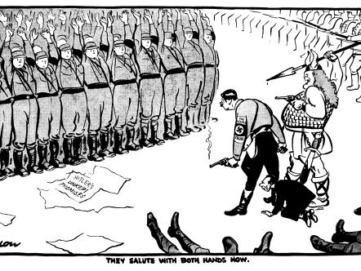

*A cartoon by David Low, which appeared in the London Evening Standard, 3rd July 1934. The caption reads ‘ They salute with both hands now’. Goering is standing to Hitler’s right, dressed as a Viking hero, and Goebbels is on his knees behind Hitler. The paper at the feet of the SA has the words ‘Hitler’s un-kept promises’, and the Swastika on Hitler’s armband is between the words ‘the double cross’.*

**Task:** What was the purpose of the source?

_________________________________________________________________________________________________________________________________________________________________________________________________________________________________________________________________________________________________________________________________________________________________________________________________________________________________________________________________________________________________________________________________________________________________________________________________________________________________________________________________________________________________________________________________________________________________________________________________________________________________________________________________________________________________________________________________________________________________________________________________________________________________________________________________________________________________________________________________________________________________________________________________________________________________________________________________________________________________________________________________________________________________________________________________________________________________________________________________________________

Hitler becomes Führer

**Task:** Complete the gap fill below…

By the end of August 1934, Hitler had become the sole leader of Germany, combining the role of Chancellor and president and giving him the title _______________.

Hitler had removed the SA so that he could gain the support of the _______________. This was successful and the army showed their support to Hitler after the SA leaders were ________________________. After Hindenburg died (August 1934), Hitler also became __________________________ of the Armed Forces. Hitler decided he needed to consult the German people before he combined the roles, so he held a ___________________. More than _____% of the voters agreed with the action.

Commander-in-Chief

Führer

army

assassinated

90

referendum

**Part V - Nazi Economic, Social & Racial Policy**

Unemployment and workers policy **Task:** Complete the gap fill below on the attempts to reduce unemployment and treatment of workers.

In 1933 Germany had experienced years of depression, with ____________ at 6 million. Hitler appealed to people because he ___________ jobs. He introduced the RAD which made it ____________ for all men between 18-25 to do six months of ____________ labour, wearing uniform and doing military drills. He also spent millions on job ___________ schemes, such as building ____________ (motorways). The Nazis also hid unemployment, with Jews, women and those held in ______________ camps not counted in the figures. ______________ also played a big role in reducing unemployment, and ___________ increased the army to 1.4 million by 1939. ___________ were also needed, which created even more jobs. By 1939 there were only 35,000 _________ listed as unemployed.

The Nazis wanted to control the workforce. They did this through banning all trade _________ and replacing them with the DAF. They decided wages, and banned __________. Membership was voluntary, but it was almost impossible to get a job without being member. It organised the ____________ scheme, where 150,000 people paid 5 marks a week for a car expected in 1940. However, it was a swindle, and none of the workers ever ___________ the car, and they weren’t _________. The ‘Strength through Joy’ (KdF) movement tried to improve the leisure time of workers, offering cheap _________, concerts, theatre trips and sporting events. Swimming _______and sports facilities were also introduced into workplaces.

refunded

compulsory

unions

promised

people

creation

strikes

Volkswagen

pools

weapons

conscription

manual

holidays

received

rearmament

unemployment

autobahns

concentration

**Task:** Using the information above, match up the terms below with their definitons.

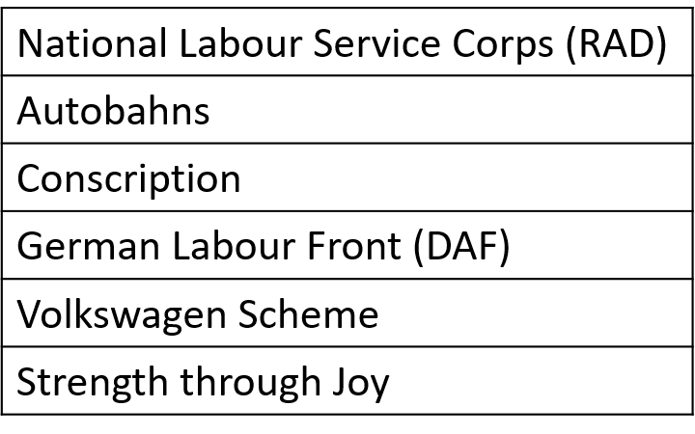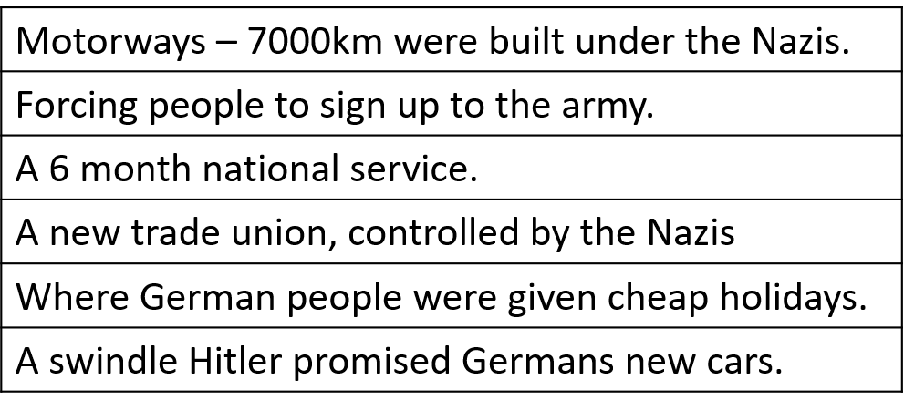

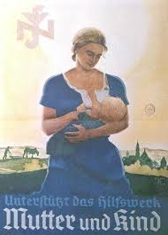The role of women

In the 1920s there had been progress in women’s rights. They were given the vote, worked as lawyers and doctors, and were allowed to drink, smoke, and wear they wanted. The Nazis had a different view of women. They believed an ideal women:

* Did not wear make-up
* Was blonde, heavy hipped and athletic
* Did not smoke
* Did not work
* Cooked, cleaned and looked after the children
* Was not interested in politics

The Nazis promoted this idea using posters, as seen here. They wanted to encourage women to have more children, as the birth rate had dropped massively. Along with propaganda, the Nazis introduced the following measures.

**Task:** Match the terms up with the correct description.

|  |  |  |
| --- | --- | --- |
| Law for the Encouragement of Marriage (1933) |  | On Hitler’s mothers birthday medals were awarded to women with large families. |
| 12th August Medals |  | A new national organisation organised classes and radio talks on household topics and motherhood. |
| Divorce Law (1939) |  | Loans were given to couples to marry, and they could keep it if they had children. |
| Lebensborn programme. |  | Unmarried women could donate a baby to the Hitler by becoming pregnant by SS men. |
| German Women’s Enterprise |  | Divorces were granted if a couple could not have children – childless marriages were seen as worthless. |

The Nazis believed in the ‘three Ks’: Kinder, Kuche, Kirche (children, kitchen, church).

**Task:** Explain what the ‘three Ks’ were, and how they fitted into Nazi beliefs.

_____________________________________________________________________________________________________________________________________________________________________________________________________________________________________________________________________________________________________________________________________________________________________________________________________________________________________________________________________________________________________________________________________________

From 1937 the Nazis had to reverse their policies, as the men were joining the army. Women were needed in work, so the Nazis introduced a ‘duty year’ for women, where they would have to do farm work for no pay. However, as a result of the Nazis policies towards women, by 1939 there were fewer women working than there had been under the Weimar Republic.

Controlling education

The Nazis saw the young as the future, and they needed to convert them to the Nazi beliefs. They did this through control of education.

**Task:** Categorise the information below into the following categories: Textbooks, Teachers, Lessons.

|  |  |  |
| --- | --- | --- |
| All books used were re-written to fit the Nazi view. | Boys curriculum was focused on preparation for the military, whilst girls learnt how to be good mothers. | Teachers had to swear an oath of loyalty to Hitler. |
| Teachers who did not promote Nazi ideals were dismissed. | New subjects like race studies were introduced, in which the Nazis promoted the Aryan race. | All books had to be approved by the Ministry of Education. |
| All lessons began with ‘Heil Hitler’, and Nazi themes were present in all lessons. | Mein Kampf, Hitler’s book, became a standard text in every school. | A Nazi Teachers’ League was set up, and by 1937 97% of teachers had joined. |

The Nazis also wanted to control the spare time of the young. Hitler believed that if young people were indoctrinated in their leisure time as well as at school they would become loyal and committed followers. They therefore:

* Banned all other youth organisations.
* Made membership of the Hitler Youth compulsory from 1939.

**Task:** For the following statements, decide if they refer to the Hitler Youth (for boys), or the League of German Maidens (for girls), or both.

* Took part in athletics, hiking and camping.
* There was a focus on domestic skills.
* Marching, map reading and camping were introduced as they became older.
* The idea was preparation for marriage.
* Members enjoyed the comradeship.
* The Nazi message would be clear.

Whilst other youth organisations were banned, they did exist. One example is the Edelweiss Pirates.

The treatment of the Jews

|  |  |  |
| --- | --- | --- |
| Many Christians blamed the Jewish people for the death of Jesus Christ. | Hitler spent several years in Vienna where there was a long tradition of anti-Semitism. During this time, he was taunted by the wealthy Jews while he himself was a failed artist. | Hitler’s mother was in the care of a Jewish doctor while she was suffering from cancer. After she passed away, Hitler held a grudge against the doctor she was under the care of. |
| Germany blamed many of their economic issues on the Jewish populace due to the incorrect stereotype that Jews were commonly known as money lenders. | Many Jewish people were targeted and blamed for starting/spreading the Black Death and poisoning wells around the villages. | Germany looked for a scapegoat for losing WWI, and many of this blame was focused on the Jewish minority at the time. |

**Task:** Colour code the reasons for persecution of Jews into: Hitler’s experience, historical anti-Semitism, and the situation Germany found itself in.

The Nazis plan was to create a pure German state. This meant treating non-German groups, especially the Jews, as second-class citizens. Hitler believed in a ‘master race’ of Aryans. He planned to achieve this through selective breeding and driving out/destroying the Jews.

Hitler needed to gain support of the German people for his policies. He did this through indoctrination and propaganda, particularly in schools. Textbooks and lessons would put across anti-Semitic views, and laws were put in place to restrict Jewish people’s involvement in education. Those Jews who were in school would be humiliated in front of the class. In November 1939 Jewish children were expelled from German schools.

**Task:** Look at the timeline of laws below. Colour-code them into political, social, and economic consequences for Jews.

|  |  |
| --- | --- |
| April 1933 | SA organised a boycott of Jewish shops and businesses. Thousands of Jewish civil servants, lawyers and teachers were sacked. |
| May 1933 | A new law excluded Jews from Government Jobs. |
| Sept 1933 | Jews were banned from inheriting land. |
| 1934 | Jews were banned from parks, playing fields and swimming pools. |
| May 1935 | Jews were no longer recruited for the army. |
| June 1935 | Jews were not allowed in restaurants. |
| Sept 1935 | The Nuremburg Laws took away Jews citizenship and banned marriage or sexual relations between Jews and Germans. |
| April 1936 | Jews were banned from being vets, dentists, nurses, accountants and teachers. |
| Sept 1937 | More Jewish businesses were taken over by the Nazis. |
| July 1938 | Jews had to carry identity cards. |
| August 1938 | Jewish men had to add the name ‘Israel’ to their first names, and Jewish women had to add ‘Sarah’, in order to humiliate them. |
| October 1938 | Jews had the red letter ‘J’ stamped on their passport. |
| Nov 1938 | Kristallnacht occurred. |

**Task:** Complete the gap fill on Kristallnacht.

In November 1938 a Polish Jew shot a ________ embassy official in Paris, as a protest against the treatment of his parents, who had been __________ by the Germany. The Nazis used this as an excuse to organise anti-Jewish demonstrations, ________ Jewish property, shops, homes and synagogues across Germany. It became known as Kristallnacht, or the ‘Night of ________ Glass’. 100 Jews were killed, 20,000 sent to ____________ camps, and 7500 Jewish businesses were _________. The owners of the property were not allowed to make any __________ claims, and were not allowed to re-open under Jewish management. Many Germans were _________ at the events, so Hitler pretended the Nazis had nothing to do with it, and that it was ____________.

attacking

destroyed

German

Broken

deported

disgusted

insurance

concentration

spontaneous

Hitler blamed the Jews, and they were fined 1 billion Reichsmarks to repair the damage. The persecution continued into 1939, with the SS forcibly removing Jews. Jewish people were required to surrender precious metals and jewellery, they were evicted from their homes and forced into ghettos, and they had to hand in their radios so they could not listen to foreign news.

**Part VI - Terror and Persuasion**

The use of the SS and the Gestapo

The Nazis used their own organisations to instil fear into the German people. The SS, SD and Gestapo were the main organisations, and they were all under the control of Heinrich Himmler.

**The SD**

* Set up in 1931 as intelligence body of the Nazis – effectively spies!
* Aims was to discover and remove enemies.
* They were employees of the Nazi party.
* Attracted many educated and professional people such as lawyers, economists and professors.

**The Gestapo**

* Secret State Police set up in 1933 by Goering.
* By 1936 it was under the control of the SS.
* It could imprison those suspected of opposing the state.
* It would send people to concentration camps.
* By 1939 160,000 people had been arrested for political crimes.

**The SS**

* Formed in 1925 as Hitler’s bodyguard.
* Wore black.
* By 1934 they had 50,000 members.
* Members were Aryan, and expected to marry racially pure wives.
* After the Night of the Long Knives they were responsible for removing opposition.
* Membership was 250,000 by 1939

**Task:** Explain which of the organisations above would have been most effective for the Nazis.

_______________________________________________________________________________________________________________________________________________________________________________________________________________________________________________________________________________________________________________________________________________________________________________________

**Task:** Complete the gap-fill on concentration camps.

Concentration camps were a new type of __________ for political, ideological and racial ___________. At first they we set up to detain __________, trade unionists and other left-wing opponents. In 1939 there were 150,000 people under arrest for _________ offences. The SA and SS ran the ________, and the ____________ sent people there. Prisoners were _____________ by different coloured _________ on their clothes. Work was initially hard and pointless, but eventually prisoners were used as forced workers in quarries, coal mines and ___________. Inmates were underfed and treated brutally. If someone was killed their family would receive a note to say they had died of _________ or been shot for trying to escape.

camps

prison

disease

opponents

categorised

triangles

communists

Gestapo

factories

political

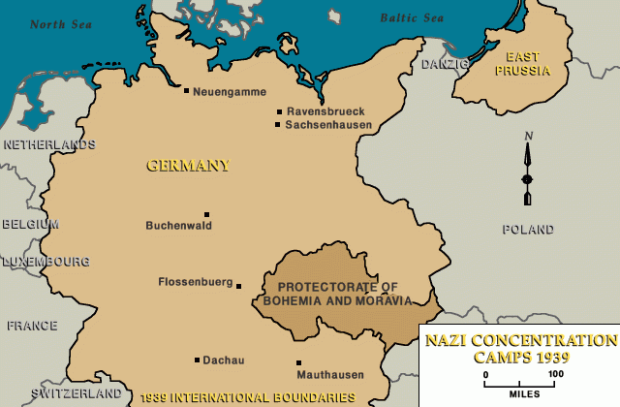

**Different categories of prisoners:**

* Political prisoners
* Foreign prisoners
* Work-shy – homeless/alcoholics.
* Sexual offenders
* Professional criminals
* Jews
* Other religious groups opposed to the Nazis

Control of the legal system

Even though the Nazis could make laws, Hitler wanted to make sure they were interpreted in a Nazi fashion. Some judges were removed, and those that remained had to become members of the National Socialist League for the Maintenance of Law. Lawyers had to swear an oath of loyalty to Hitler. In 1934 a People’s Court was set up to try cases of treason. Judges were loyal to Hitler, and sometimes Hitler would adjust sentences if they were too soft. From 1936 judges had to wear the swastika and Nazi eagle on their robes.

**Task:** Explain why control of the legal system was for Hitler and the Nazis.

_______________________________________________________________________________________________________________________________________________________________________________________________________________________________________________________________________________________________________________________________________________________________________________________

**Task:** Match up the different methods of terror with their descriptions.

|  |  |  |
| --- | --- | --- |
| SS |  | A prison for political, ideological and racial opponents of the Nazis |
| Gestapo |  | Nazi intelligence body with the aim of discovering actual and potential enemies. |
| SD |  | Began as Hitler’s bodyguard and became responsible for removing all opposition. |
| Legal System |  | Secret State Police group, under SS control. |
| Concentration Camps |  | Made to interpret laws in a way the Nazis would approve of. Hitler could adjust sentences. |

Goebbels and propaganda

In 1934 Goebbels set up the Ministry for Popular Enlightenment and Propaganda to control the thoughts, beliefs and opinions of the German people. It was important that the majority of the population believed in the ideals of the Nazi party.

**Task:** Categorise the following statement about propaganda to show whether they refer to radio, cinema, rallies, posters or books.

|  |  |  |
| --- | --- | --- |
| All films included a 45 minute advertisement about how great the Nazis were. | We put everywhere in public so people could see them and take in their message. | All plots were shows to Goebbels before they were produced. |
| Writers were forced to praise Hitler and his achievements. | By 1939, 70% of German families owned one. They were also installed in public. | These were held to show how powerful and popular the Nazis were. |
| They lacked shortwave reception, which meant Germans could not hear foreign broadcasts. | The annual one was held at Nuremburg, with almost one million people coming to watch. | Students burnt 20,000 of these written by Jews, communists and anti-Nazi professors. |
| Hitler ordered anti-Semitic films to be made. | About 2500 writers left Germany. | All stations were under Nazi control. |

**Task:** Which of the above methods do you think would have been the most effective? Explain your answer.

_______________________________________________________________________________________________________________________________________________________________________________________________________________________________________________________________________________________________________________________________________________________________________________________

Censorship of newspapers and the arts

All aspects of the media were censored by Joseph Goebbels – the Nazi Propaganda Minister. Anything he felt was unsuitable was banned, with many people leaving Germany as a protest.

**Task:** For each of the following forms of censorship, think of a heading. The first one has been done for you.

* HEADING: Newspapers

Editors were told what to print, which meant German people only read what the Nazis wanted them to. Non-Nazi newspapers were closed down. Editors could be arrested. By 1935 the Nazis had closed down 1,600 newspapers and thousands of magazines. Any foreign news had to be taken from the Nazi-controlled German Press Agency.

* HEADNG:

Jazz was seen as racially inferior and banned. The Nazis encouraged German folk music and classical music. Richard Wagner was promoted, as he was Hitler’s favourite composer.

* HEADING:

Cheap tickets to see plays were made available, which had a Nazi political or racial theme. They focused on German history and political drama.

* HEADING:

Hitler encouraged large buildings made of stone showing the power of Germany. Old fashioned country style buildings were used to family homes, taking pride in Germany’s past. Hitler admired the Greek and Roman style of building because he said the Jews had not ‘contaminated’ it.

* HEADING:

Hitler believed he was an expert in art. He hated modern art, which he believed was unpatriotic and Jewish, so he banned it. It was replaced with art which highlighted the greatness of Germany. He wanted art that glorified strong, healthy people. All new public buildings had to have sculptures which shows Nazi ideals.

**Part VII - Hitler’s Foreign Policy**

Hitler’s foreign policy aims

Hitler had promised to make Germany great again, and he had five aims to help him achieve this. He wrote about these in his book, ‘Mein Kampf’.

**Task:** For each of the aims, explain what it means and why Hitler wanted to do this.

* Reverse the Treaty of Versailles:

* Unite all German-speaking people:
* Destroy communism:
* Lebensraum (living space):
* Anschluss (with Austria):

In 1932, 60 nations met to discuss ways in which their countries would disarm to reduce the chances of a war. However, it failed to achieve anything. A year later, Hitler said this:

“Germany is at any time willing to undertake further disarmament… if all other nations are ready to do the same”.

The other countries were reluctant to reduce their military, so instead Hitler announced that the German army would increase to 300,000, and he was setting up an Air Ministry. This broke the Treaty of Versailles, but nothing was done. Germany also withdrew from the League of Nations.

**Task:** Explain why the Disarmament Conference was key in shaping Hitler’s Foreign Policy.

_______________________________________________________________________________________________________________________________________________________________________________________________________________________________________________________________________________________________________________________________________________________________________________________

The Rhineland 1936

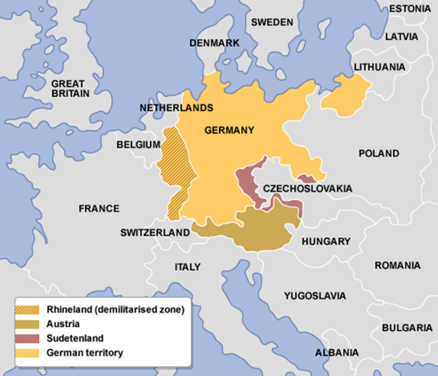The Rhineland had been demilitarised under the Treaty of Versailles, and this was confirmed by the Locarno Pact. In 1936 Hitler denounced Locarno, and moved his troops in the Rhineland. Hitler was ready to withdraw if he was challenged by Britain or France, but they did not react. This convinced Hitler that Britain and France were unlikely to act against further aggression. Hitler held a vote in Germany, which showed 99% of people supported his decision. This led Hitler to challenge the Treaty of Versailles even further.

**Task:** Put these events into the correct order.

|  |  |
| --- | --- |
| **Order** | **Event** |
|  | However, France, along with Britain, did not oppose the move. |
|  | Hitler had begun rearming Germany – increasing its military |
|  | Hitler claim Germany was being encircled, and used this as justification for moving troops into The Rhineland. |
|  | The Treaty of Versailles had ordered that Germany was not allowed troops in the Rhineland. |
|  | In 1935 Hitler introduced conscription. |
|  | This led Hitler to become more confident in terms of foreign policy. |
|  | Hitler was ready to withdraw troops should France oppose him. |
|  | Hitler asked the people in a referendum whether they supported his re-occupation. 98.8% said that they did. |

Anschluss 1938

Hitler had tried to unite with Austria in 1934, but this failed due to his fear of Mussolini. However, by 1938 he was much more confident. His army was bigger, Mussolini was now an ally, and the Nazi Party in Austria were stronger. This led him to attempt the Anschluss once again. The events are below:

* Hitler encouraged the Austrian Nazi Party to stir up trouble, staging demonstrations demanding a union with Germany.
* Hitler ordered bombings of public buildings and mass rallies.
* Hitler bullied the Austrian Chancellor, Schuschnigg, into accepting two Austrian Nazis into his cabinet.
* Schuschnigg held a vote on the future of Austria.
* Hitler threatened invasion – he bullied Schuschnigg into resigning. Hitler sent troops to restore order.
* The Anschluss was proclaimed.
* 99.75% of Austrians voted in favour of the Anschluss.

Britain and France protested, but ultimately did nothing. They were following a policy of appeasement – trying to avoid a war at all costs. Once again Hitler had broken the rules, and got away with it.

**Task:** Explain which of Hitler’s aims the Anschluss achieved. (Clue: there are several!)

_______________________________________________________________________________________________________________________________________________________________________________________________________________________________________________________________________________________________________________________________________________________________________________________

The Sudetenland Crisis 1938

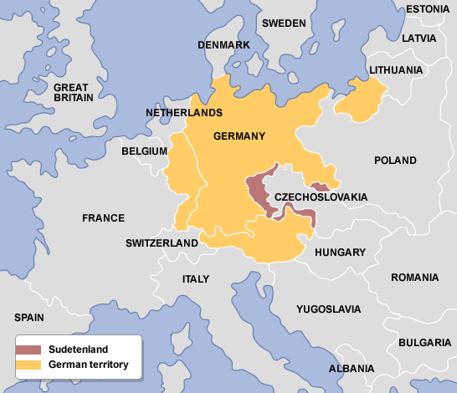The Sudetenland was part of Czechoslovakia, and it contained 3 million Germans. It also had valuable factories and industry. This made Hitler want to take over. He ordered the Sudeten Nazi Party to stir up trouble. Hitler then used this ‘crisis’ to threaten to use military force. The Czechs did not want to surrender the Sudetenland because a lot of their military defences were based there. They believed the French would support them.

See the timeline of events for what occurred next.

|  |  |
| --- | --- |
| 15th September 1938 | Hitler demanded the Sudetenland and threatened war. Chamberlain (British PM) offered to discuss the matter, and the Czechs were forced to agree. |
| 22nd September 1938 | Hitler increased his demands, saying land should be given to Poland and Hungary as well, threatening war if his demands weren’t met by 1st October. Britain and France rejected his demands. |
| 29th September 1938 | The leaders of Britain, France and Italy meet with Hitler at the Munich Conference. They agree that Sudetenland will be given to Germany, with Poland and Hungary also receiving land. The leader of Czechoslovakia wasn’t invited to the talks. |
| 30th September 1938 | Hitler and Chamberlain signed an agreement, agreeing never to go to war with each other. This was greeted positively in Britain, as war had been avoided. |

**Task:** Match up the following countries to their consequences of the Munich Conference.

|  |  |
| --- | --- |
| Czechoslovakia | They realised that opposition was weak, and their leader gained more confidence. They also gained a lot of important industrial land. |
| Britain | Their leader was furious that he wasn’t invited to the conference. They felt they would not have support if Hitler attacked them. |
| France | Land was lost to Germany, Poland and Germany, and they had been deserted by their allies. |
| Germany | They supported Germany throughout, and their leaders became even closer. |
| The USSR | There was a huge sense of relief that there was not going to be a war. Their leader was greeted like a hero. |
| Italy | There was massive relief that war was avoided, especially as they shared a border with Germany. |

In March 1939 Hitler took over the rest of Czechoslovakia. This showed he could not be trusted, and led Britain and France to abandon their policy of appeasement.

The Nazi-Soviet Pact and the Outbreak of War

On August 23 1939, Germany and the Soviet Union signed an agreement, called the Nazi Soviet Pact. This was a surprise, as Germany and the Soviet Union had completely different political ideas. The agreement said that:

* Germany and the Soviet Union would not support a third country if it attacked the other.
* They would not join an alliance aimed at the other.
* They would secretly invade and divide up Poland.

Hitler was pleased with this because it meant he would not be faced with a war on two front, and it meant he was closer to the Soviet Union for a potential future invasion. Stalin was pleased because he could take over parts of Poland, which would make it harder for him to be invaded in the future.

**Task:** Look at the cartoon on the next page. What is the message?

_______________________________________________________________________________________________________________________________________________________________________________________________________________________________________________________________________________________________________________________________________________________________________________________

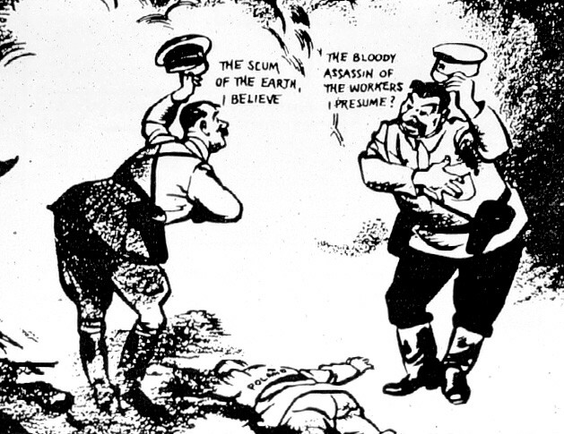

On 1st September 1939 German troops invaded Poland. The British and French governments decided to honour their promise to Poland to defend them. They gave Hitler an ultimatum demanding he withdraw his troops. He did not, and on 3rd September Britain and France declared war on Germany.

**Task:** Match up these key terms from Hitler’s foreign policy with their definition.

|  |  |  |
| --- | --- | --- |
| Lebensraum |  | An agreement made between Hitler and Stalin to divide up Poland between them. |
| Anschluss |  | Increasing the military power of Germany. |
| Rhineland |  | Hitler’s policy of increasing the amount of land that Germans could live in. |
| Communism |  | An agreement made between Hitler and Chamberlain to never go to war. |
| Re-armament |  | An area occupied by German speakers in Czechoslovakia, that Hitler wanted to take over. |
| Conscription |  | A strip of land between on the German-French border that Hitler was forbidden from putting his troops. |
| Sudetenland |  | A political ideology that Hitler hated, that was popular in the Soviet Union. |
| Munich Agreement |  | A union with Austria. |
| Nazi-Soviet Pact |  | Forcing people to join the army. |