**Q: Use sources A, B and C to identify one similarity and one difference in forms of entertainment over time. [4]**

[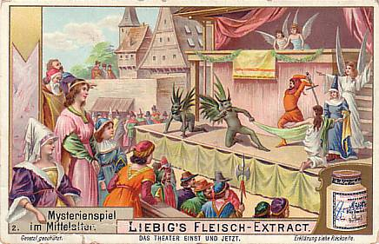](https://www.google.co.uk/url?sa=i&rct=j&q=&esrc=s&source=images&cd=&cad=rja&uact=8&ved=0ahUKEwiqxbK1ps7YAhVqBcAKHSQQBvAQjRwIBw&url=https://blockleymysteryplays.wordpress.com/the-medieval-mystery-plays/&psig=AOvVaw2QIaG88bFh-c39j7dOQ5EX&ust=1515704767263465)

**Source A**

*[Picture of a mystery play from one of four English towns – Chester, Coventry, Lincoln, Wakefield and York. Dates from the 1300's.]*

[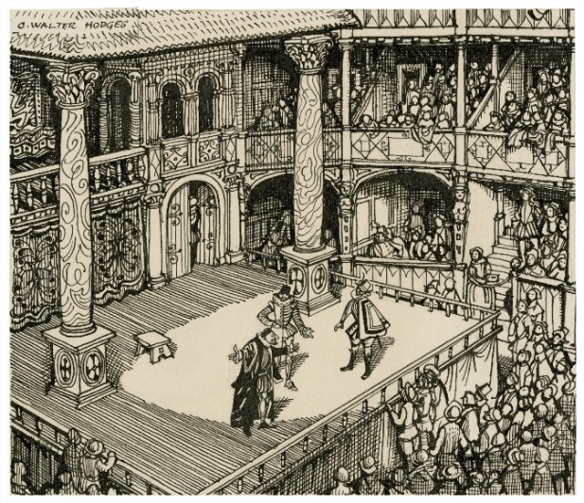](https://www.google.co.uk/url?sa=i&rct=j&q=&esrc=s&source=images&cd=&cad=rja&uact=8&ved=0ahUKEwjw46-mp87YAhUoAsAKHZzJAvQQjRwIBw&url=https://commons.wikimedia.org/wiki/File:Imaginary_view_of_an_Elizabethan_stage.jpg&psig=AOvVaw3U_KKp8r9P5ceZl9w0li75&ust=1515704959400052)

**Source B**

*[View from an Elizabethan theatre.]*

[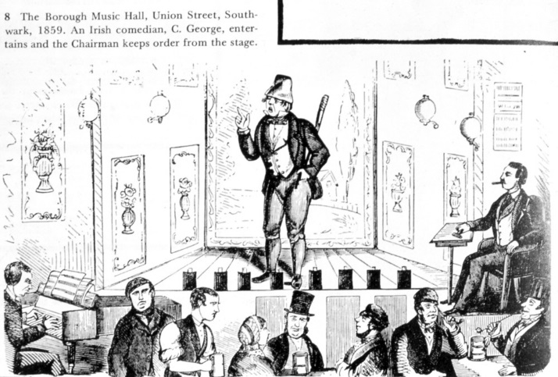](http://www.google.co.uk/url?sa=i&rct=j&q=&esrc=s&source=images&cd=&cad=rja&uact=8&ved=0ahUKEwisqeuSqs7YAhWpB8AKHejRBd4QjRwIBw&url=http://www.vam.ac.uk/content/articles/t/the-story-of-music-halls/&psig=AOvVaw3CtxGnyTBiEFcjROYqpAwb&ust=1515705651447187)

**Source C**

***[A Victorian music hall.]***

**Mark scheme:**

|  |  |  |  |  |
| --- | --- | --- | --- | --- |
|  | **AO2 (2 marks)** | | **AO3 (2 marks- source analysis)** | |
| **BAND 2** | You have identified one similarity and one difference. | 2 | You have used the sources to identify both similarity and difference. | 2 |
| **BAND 1** | You have identified either one similarity or one difference. | 1 | You have used the sources to identify one similarity or difference. | 1 |

**Model answer:**

**Q: Use sources A, B and C to identify one similarity and one difference in holidays and travel over time. [4]**

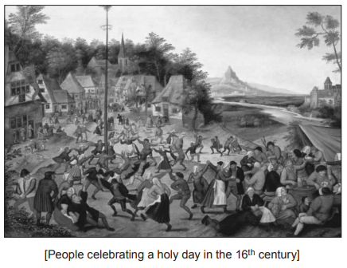

**Source A**

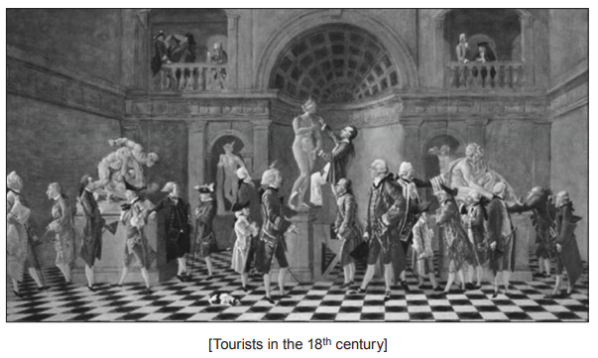

**Source B**

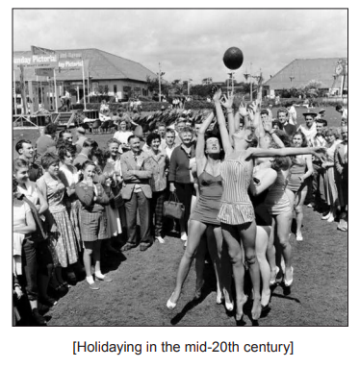

**Source C**

One similarity between sources A and C is that they show outdoor, communal activities, such as dancing and sports. One difference between sources A and B is that source A shows ordinary people, whereas source B show wealthy people on the Grand Tour participating in more cultural activities.