**Question 5 - 16 Marks - Mock Question**

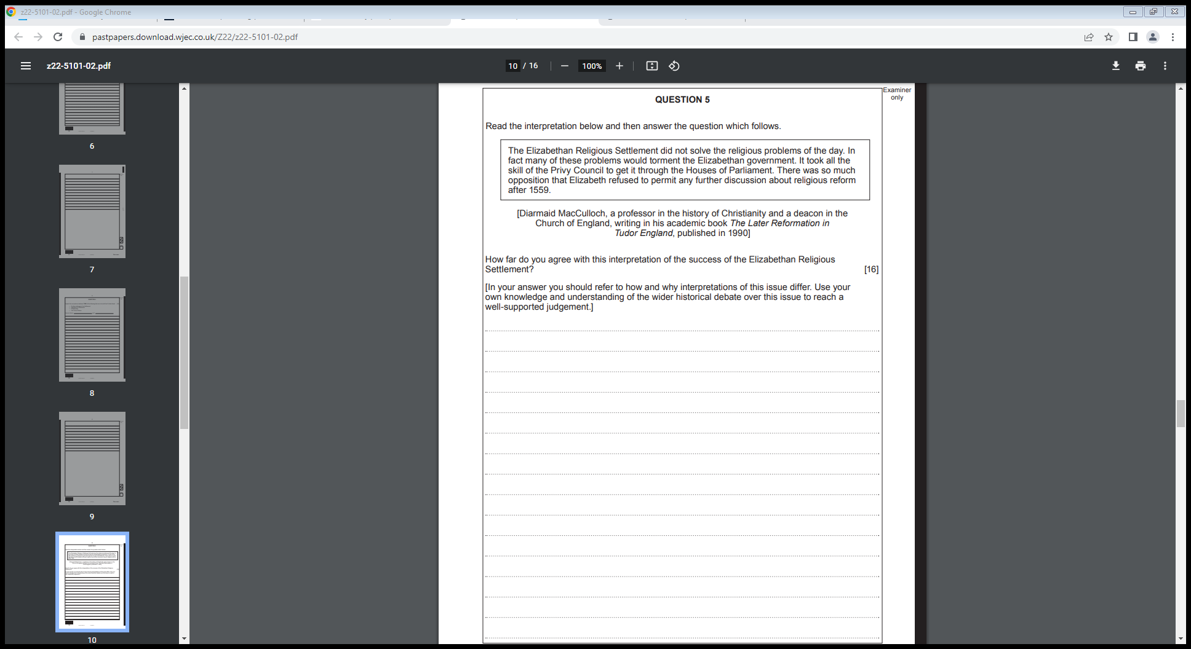

**Mark scheme:**

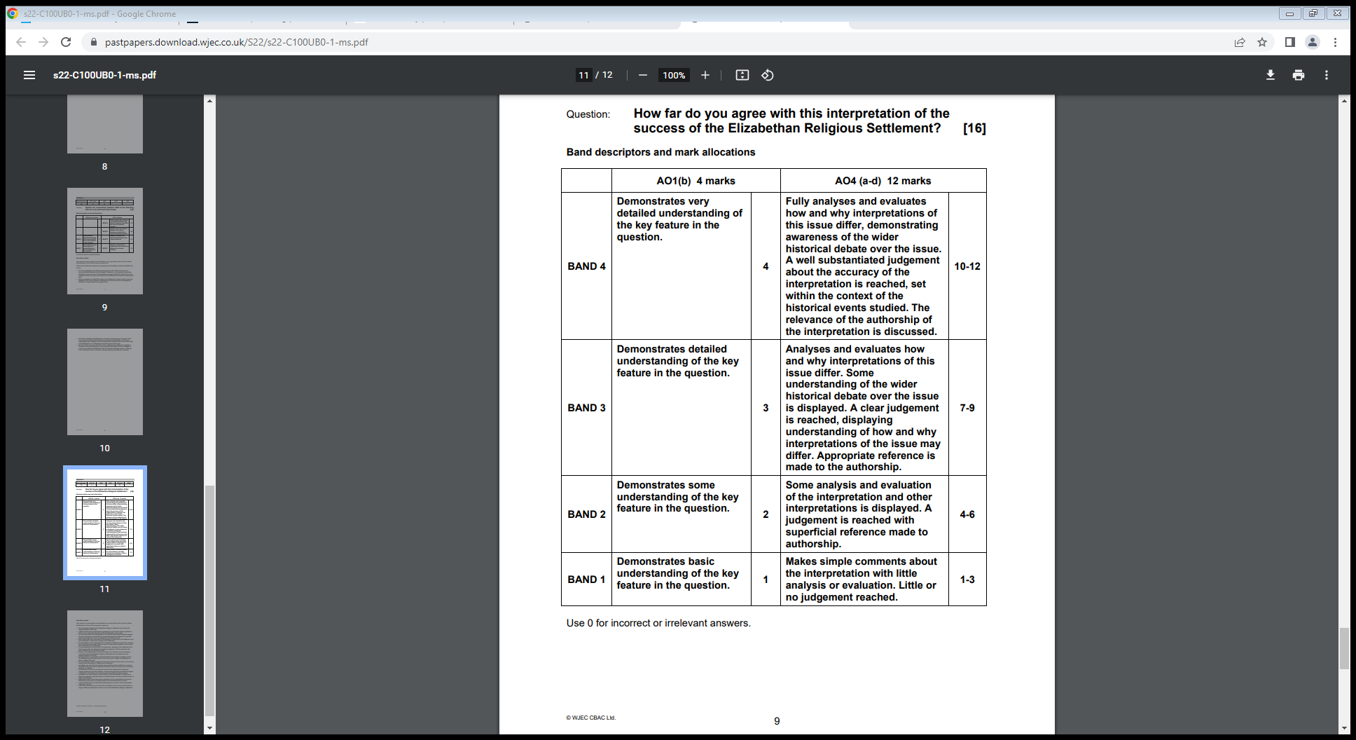

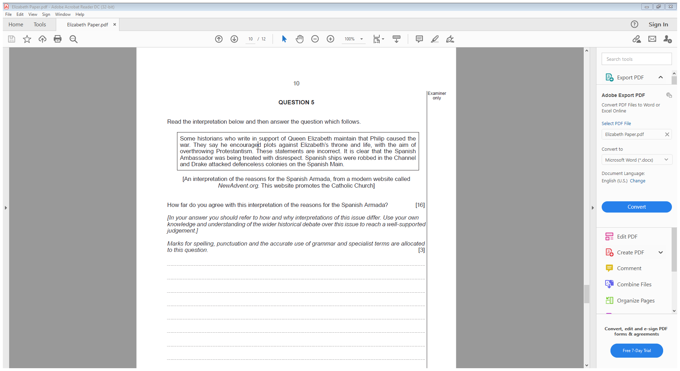

**Model answer:**

*On the one hand the interpretation is accurate as it talks about how Elizabeth brought the Spanish Armada upon herself due to her behaviour towards Spain. From my own knowledge I know that Elizabeth encouraged Sir Francis Drake to rob Spanish ships – he stole £140,000, which is worth £200 million today. This angered Philip, however Elizabeth did not punish Drake. Instead she knighted him. Therefore, the interpretation is accurate as to some extent Elizabeth did bring the Armada upon herself.*

*However, in some ways the interpretation in inaccurate. It claims it is not correct that Philip encouraged plots against Elizabeth. From my own knowledge I know that Philip and Spain were involved in several plots to overthrow Elizabeth and replace her with the Catholic Mary Queen of Scots. The plots included the Ridolfi, Throckmorton and Babington plots. After one of these the Spanish Ambassador was expelled. Therefore, the source is inaccurate when it says that Philip did not encourage plots.*

*The source is also inaccurate when it claims Philip did not have the aim of overthrowing Protestantism. From my own knowledge Philip was deeply religious, and followed the word of the Pope. In 1570 the Pope issued a Papal Bull of Excommunication against Elizabeth, with the aim of overthrowing Protestantism. This led him to attempt several plots of get rid of Elizabeth. Therefore, the interpretation is not accurate when it says Elizabeth wanted to get rid of Protestantism.*

*Furthermore, the source is written on a website, which could make it less accurate as we do not know whether the author has any expertise. It is also biased as it promotes the Catholic church, and would therefore favour Spain over Elizabeth, and want to make it look as though Elizabeth started the war.*

*Overall, I mainly disagree with the interpretation. Whilst it is true that Drake did rob Spanish ships, it was Philip’s behaviour, encouraged by the Pope, that was the main reason for the Spanish Armada. The interpretation is biased, and does not acknowledge Philip’s role in the conflict.*