**Question 4 - 10 Marks - Mock Question**



**Mark scheme:**

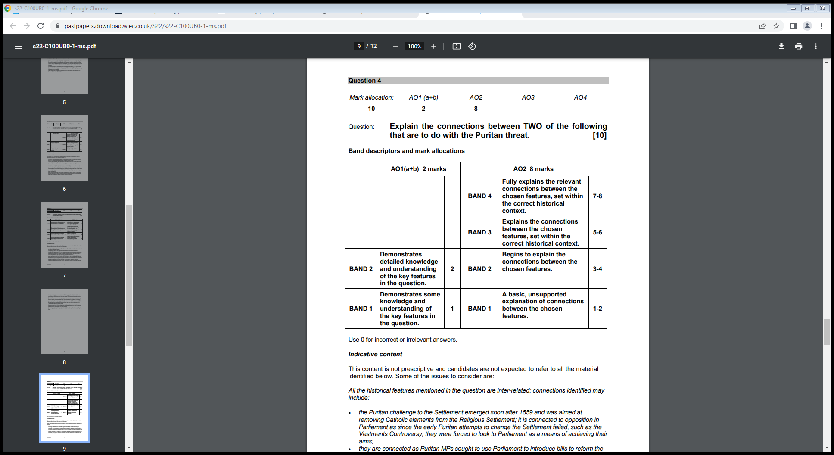



**Model answer:**

*One cause of poverty during Elizabethan times was population growth. I know that the population increased from 2.7 million to 4.1 million during Elizabeth’s reign. This caused poverty because there were more people who needed food, and not enough food was being produced.*

*Another cause of poverty was sheep farming. This was when farmers stopped farming crops, and instead chose to farm sheep as they realised they could sell the wool and make more money than they could from crops. This caused poverty as there was less food being produced.*

*Population growth and sheep farming are connected because they both cause a lack of food production, which contributed to the rise in poverty during Elizabethan times. With the higher demand caused by the increased population and the lower availability of food due to increased sheep farming, this caused a rise in prices, contributing to poverty.*