**Question 3 - 12 Marks - Mock Question**

**Why was popular entertainment a significant feature of Elizabethan society? [12]**

**Mark scheme:**

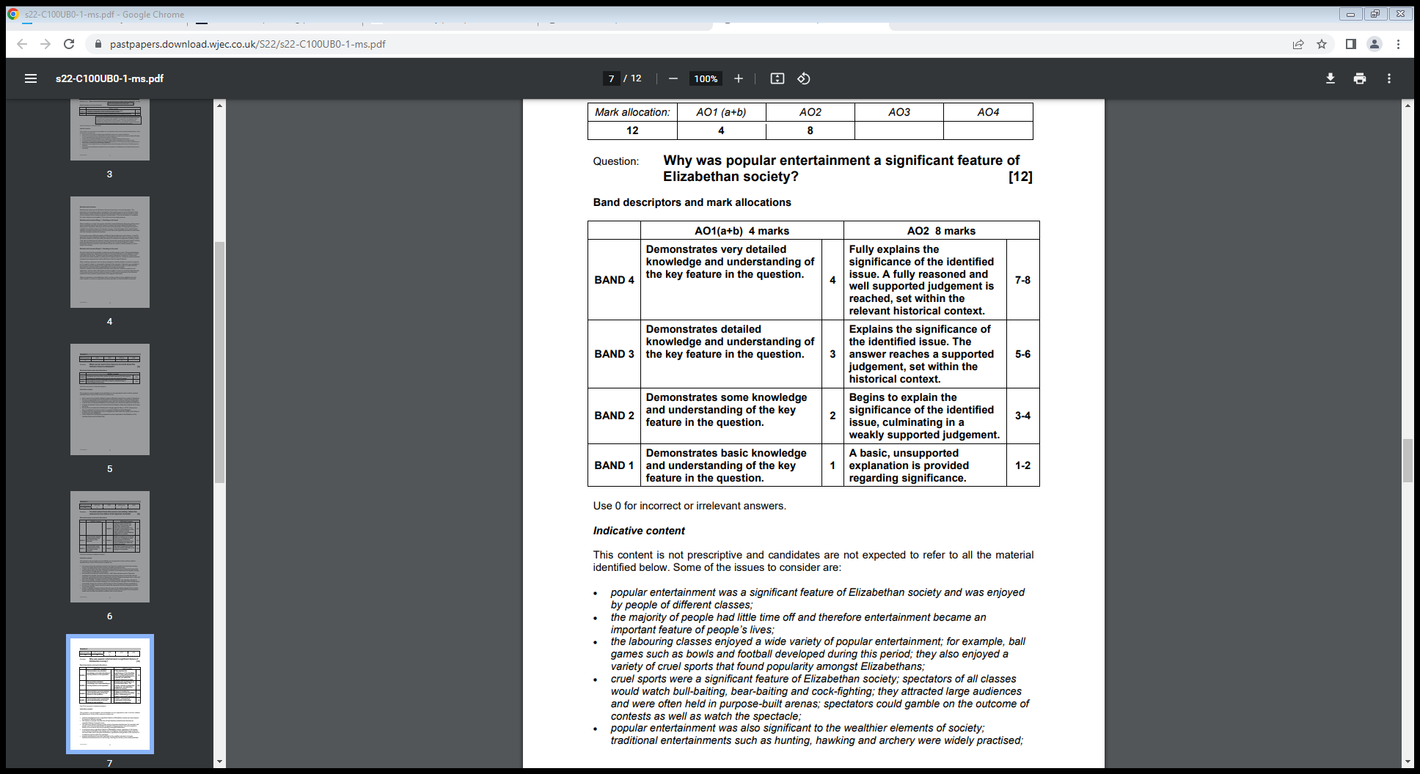

Why was the ‘Middle Way’ significant in dealing with the problem of religion during this period? [12]

**Model answer:**

*One reason that the ‘Middle Way’ was significant in dealing with the problem of religion during this period was that it was very clear what was expected on people. From my own knowledge I know Elizabeth passed two laws, the Act of Uniformity and the Act of Supremacy. These laws made it very clear how people were expected to worship and how they should behave in church. The Act of Supremacy made Elizabeth the Supreme Governor of the Church, whilst the Act of Uniformity made all churches the same. Therefore, it was significant is making sure people worshipped in the way Elizabeth wanted.*

*Another reason was that it put into place many features that the Protestants would approve of. For example, replacing the Pope as the Head of the Church with Elizabeth would have pleased the Protestants. They would have also liked the fact that the Bible was in English. This meant that the Protestants would be much happier under the reign of Elizabeth than her sister Mary, when many Protestants were burned to death.*

*One final reason why the ‘Middle Way’ was significant was that the Catholics could also accept some aspects of the Settlement. For example, Elizabeth allowed the churches to maintain the fancy ornaments and the elaborate decorations that the Catholics enjoyed. Therefore, this meant that the Catholics could accept the Middle Way due to the fact it included some aspects they enjoyed.*

*Overall, the Religious Settlement was significant as it made a compromise between the two rival forms of Christianity. Although neither side were totally satisfied, it did mean that most people accepted her Religious Settlement.*