**Question 2 - 8 Marks - Mock Question**

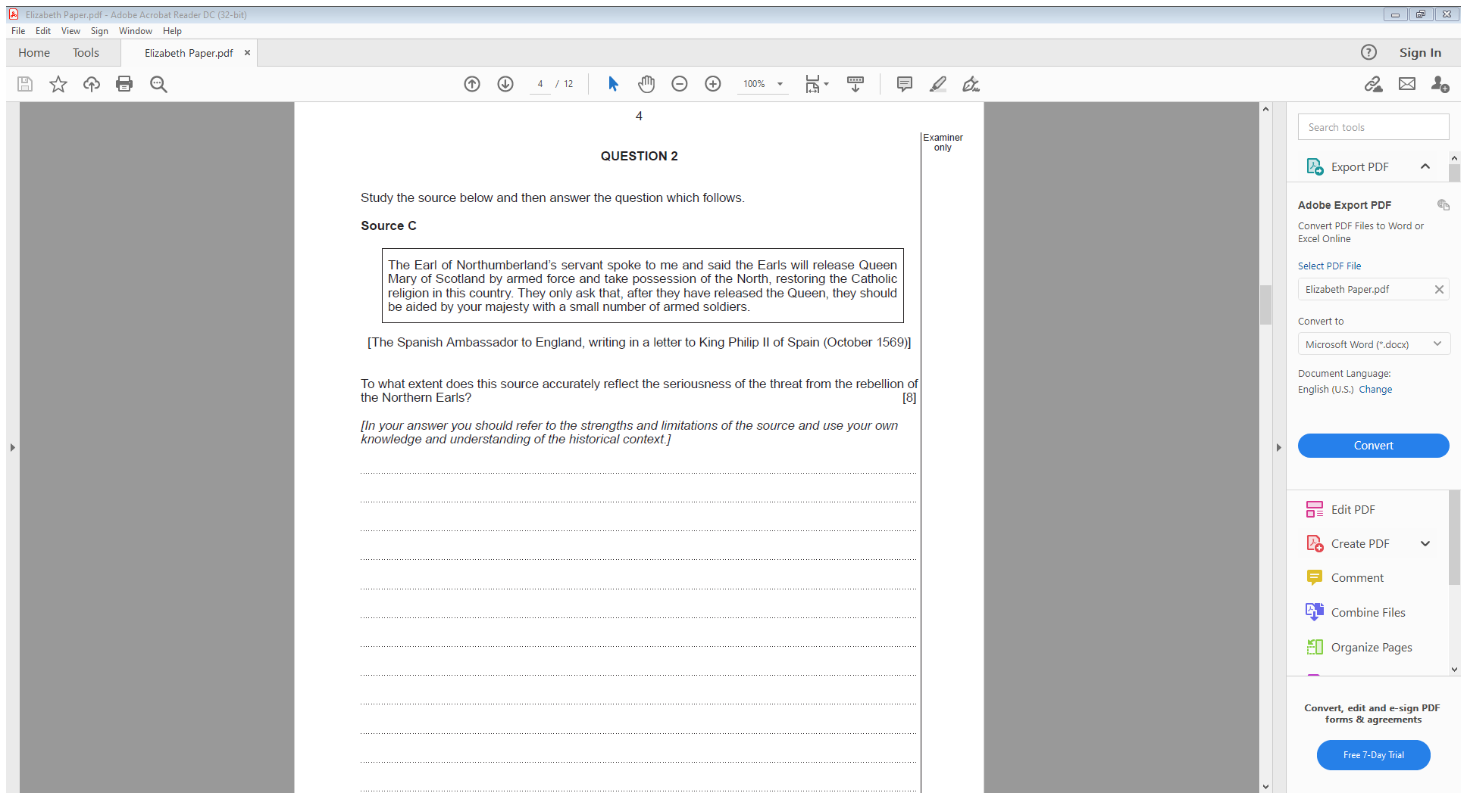

**Mark scheme:**

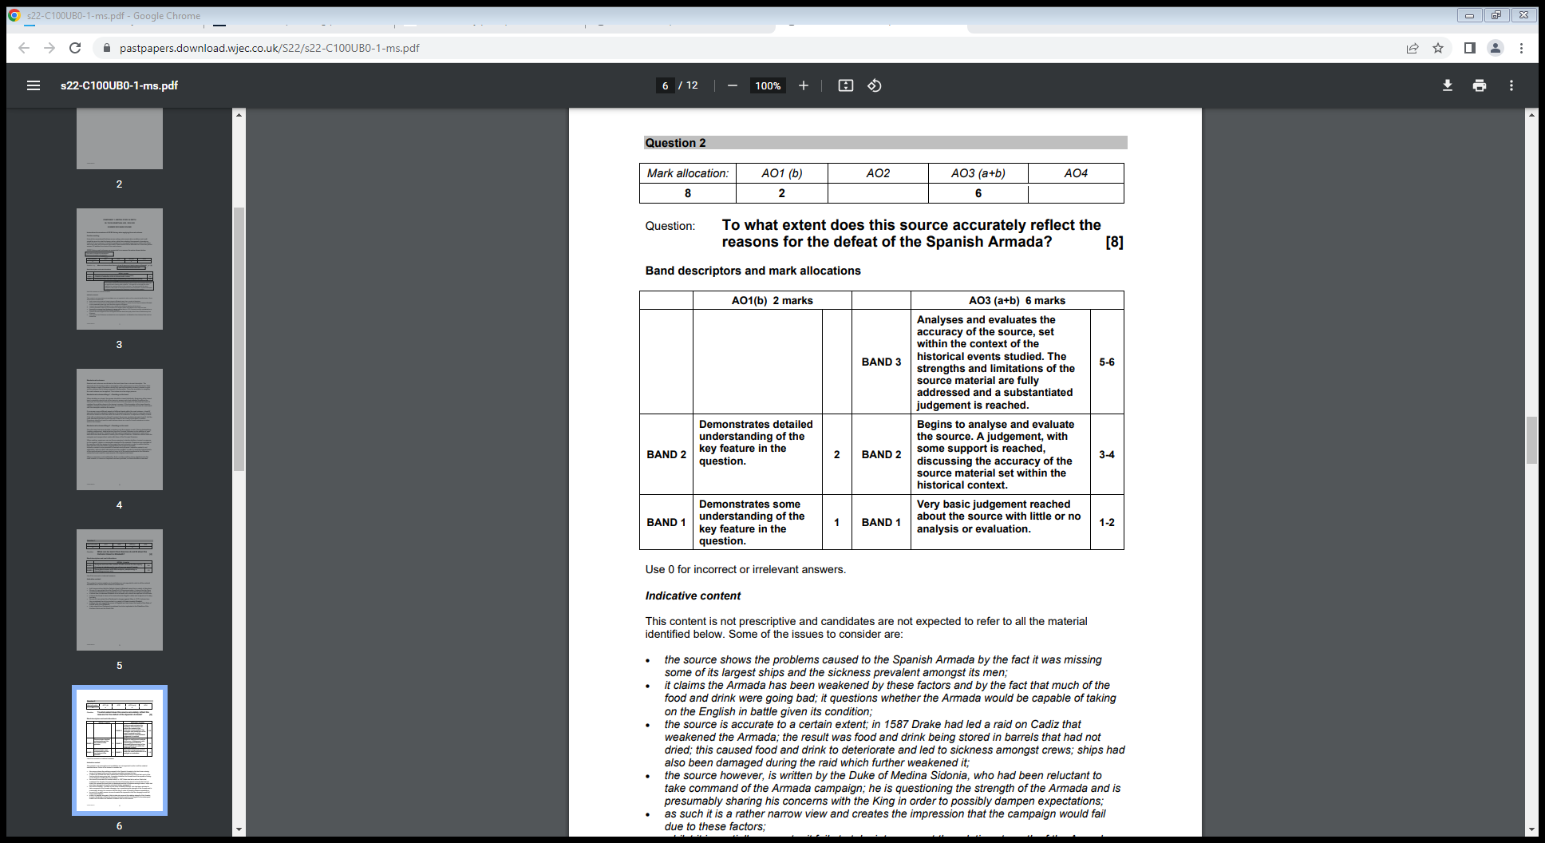

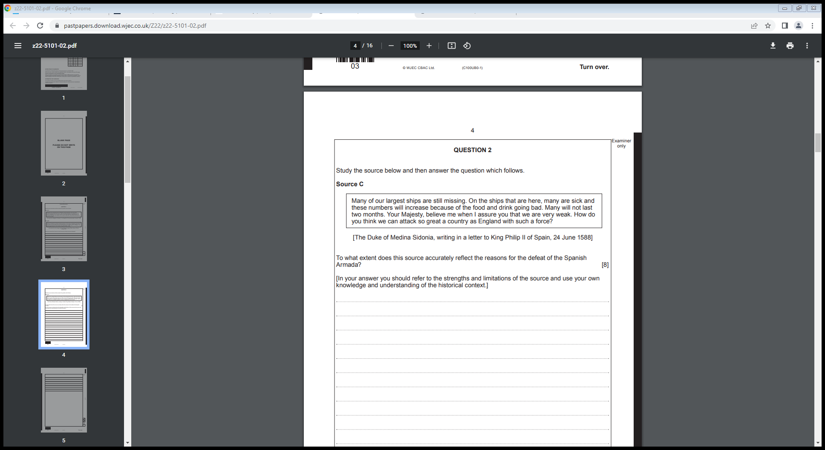

**Model answer:**

*On the one hand the source is accurate as it talks about how many ships were missing following the Battle of Gravelines. It is true that many Spanish sailors were taken ill, and that this meant they were severely outnumbered by the English. From my own knowledge I know that 1000 Spanish were killed in the battle, compared to just 50 English. Therefore, the source is somewhat accurate.*

*On the other hand, the source is less accurate as a bigger reason for the defeat of the Spanish Armada were the tactics of the English. From my own knowledge I know that Sir Francis Drake used the tactic of fireships being sent towards to Spanish ships in order to break their crescent formation. This allowed the English to defeat the Spanish. Therefore, it is not accurate to say that the Spanish lost because they were weak. Additionally, the source is written by the Duke of Medina, who was in charge of the Spanish Armada. Therefore, it is biased, as he would not want to admit the Spanish lost due to poor tactics, and therefore would look for another reason.*

*Overall the source is mostly inaccurate. Although the Spanish were weak following the Battle of Gravelines, the main reason they lost was because of the poor tactics they had compared with the English.*